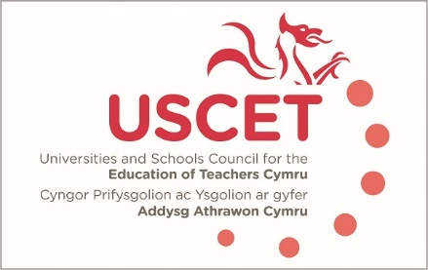

Agenda for the meeting of the University and Schools Council for the Education of Teachers (USCET) to be held on-line at 10am on Thursday 15 October 2020

- Welcome & introductions
- Minutes and matters arising (enc.)
- WG research project: parental involvement (Jane Goodall, 10mins)
- USCET PCET working group update, 10 mins)
- Covid 19: discussion of institutional issues and strategies; USCET survey; and issues to raise with WG, Estyn and EWC (45 mins)

(11am, WG, Estyn & EWC colleagues join meeting)

- Covid policy issues:
  - Correspondence with minister (encs.)
  - USCET summary of institutional Covid 19 issues (enc.)
  - Other Covid 19 issues
- Reports from:
  - Welsh Government
  - Estyn
  - Education Workforce Council
- Any other business
- Date of next meeting: 4 February 2021 (on-line)

