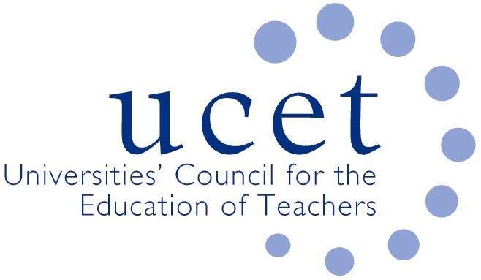
A Registered Charity (No 275082)

9-11 Endsleigh Gardens, London WC1H 0EH

T: 020 7621 6836
info@ucet.ac.uk

Promoting Quality in Teacher Education

SYSTEMATIC SYNTHETIC PHONICS AND THE OfSTED ITE INSPECTION FRAMEWORK

The new Ofsted Framework for the Inspection of ITT Providers in England has been recently published and it is clear Systematic Synthetic Phonics (SSP) continues to be central to the government’s approach to the teaching of early reading and must be covered in all primary ITE programmes. It is also required to be covered through references in the 2012 teacher standards (Part 1, Pg. 11) and the Core Content Framework (Pgs.6; 14 & 15).

There has been some discussion about the extent to which the new OfSTED Framework allows for other approaches to the teaching of early reading to be covered. UCET members believe in the intellectual nature of learning and as such are committed to introducing trainee teachers to a range of approaches to teaching & learning, including the teaching of early reading. It is important that this is approached in an intellectually critical way considering current research findings. This will prepare new teachers to teach the present curriculum effectively and be adaptable enough to manage any future changes.

In Save The Children’s 2016 report, ‘Read On. Get On’ the authors recognise the importance of teachers teaching synthetic phonics and support the government’s emphasis in embedding the practice in schools. It draws on Education Endowment Fund research and states:

Teachers need to know not only how to teach phonics effectively but also how to teach the other aspects of reading which cannot be addressed through phonics teaching. In particular, it is important that teachers have professional development in effective assessment as well as in the use of particular phonic techniques and materials. (p 18)

While Ofsted’s draft framework was at best ambiguous and at worst preventative of other forms of early reading being covered, in UCET’s view the final version does include some flexibility to cover alternatives that complement (although do not compete with) SSP. For example, in the consultation report is states that:

“All of this does not mean that trainees cannot be made critically aware that other methods for teaching reading exist. However, the clear expectation in the ITE inspection handbook is that partnerships will train trainees to teach SSP in line with government expectations. (consultation report)

In addition, there are several phrases, within the Ofsted Framework that allude to the teaching of other methods for early reading, for example:

“inspectors will focus on early reading, including phonics and the foundation subjects as a whole” (Para 62, Pg 16)

“Inspections of primary and EY phases will always include a focused review and trainee visits on early reading, including phonics, and foundation subjects. (Para 75, Pg 19)

Inspectors must inspect early reading, including phonics when looking at early years and primary training courses (Para 81, Pg20)

The above coupled with clear statements with the Framework, for example:

“Informed by up-to-date or pertinent research - The curriculum ensures that trainees are taught how to apply principles from scholarship relevant to their subject and phase when making professional decisions. Trainees learn how to assess the appropriateness and value of new approaches that they might encounter in future by: considering the validity and reliability of any research on which the approach depends; considering its context in existing community debates (for example, subject, phase, SEND, psychology); and relating it to their professional experience. (Pg 39)”
or
“Subject and curriculum - The ITE curriculum provides a systematic and critical introduction to key educational traditions, practices and debates within the trainees’ specialist subject(s) and/or phase(s). It ensures that trainees have sufficient subject knowledge to identify and evaluate content for their teaching, considering matters of scope, coherence, sequencing and rigour. Trainees are taught to identify appropriate pedagogies that secure the curriculum intent” (Pg 39)
or

“Classroom practice - The ITE curriculum introduces trainees to up-to-date research on effective classroom practice. This includes research on how to present subject matter clearly and explicitly, promoting appropriate discussion, reflection and questioning, and on how to use relevant pedagogy to enable effective teaching of the subject/specialist area” (Pg 39/40)

suggest that Ofsted should not penalise a provider for including other approaches to the teaching of early reading.

It should also be noted that the descriptor for the ‘inadequate’ grade refers to a provider falling into this category if it teaches non SSP approaches to de-coding, which is different from early reading as a whole. (Ofsted Framework Pg. 44, under ‘Designed around subject phase').

ITE providers must still ensure that the teaching of SSP is sufficiently covered and that their trainees are able to teach SSP effectively in the classroom as this will form a central focus for any inspection. (see below):

“Inspectors should ensure that they also consider trainees’ knowledge and practice……… and (early years and primary only) in systematic synthetic phonics” (Para 108)
The document also states that:

“In primary phase programmes, training ensures that trainees learn to teach early reading using systematic synthetic phonics, as outlined in the ITT core content framework, and that trainees are not taught to teach competing approaches to early reading”

This last statement is in our view inappropriate and represents an infringement on academic freedom and discussion. We should also remember that phonics is one strategy and SSP is the preferred method for it but teachers use a range of methods (including phonics) to teach early reading and we need to equip all trainees to support children effectively in learning to read.
This paper reflects UCET’s position as being one in which teachers are valued as being confident & competent individuals, epistemic agents of change and are able to engage in enquiry-rich practice as outlined in our position statement on the intellectual basis of teacher education.

UCET
July 2020

