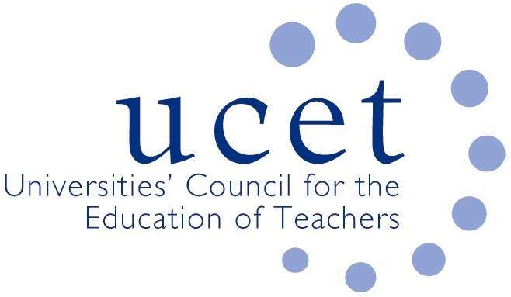
A Registered Charity (No 275082)

9-11 Endsleigh Gardens, London WC1H 0EH

T: 020 7621 6836
info@ucet.ac.uk

Promoting Quality in Teacher Education

Note of the meeting of the UCET Research & International Forum held remotely at 9.30am on Tuesday 12 May 2020

Welcome, introductions and note of the previous meeting

Forum colleagues were welcomed to the meeting. The note of the meeting held on 21 January 2020 was approved. There were no matters arising not already included on the meeting agenda.

Discussions:

Forum members discussed a range of issues linked to the meeting agenda, including:

- UCET updates, including: DfE and UCET actions in the light of the Covid 19 pandemic; and UCET’s call for delays to be made to the introduction of the ITE Core Content Framework and the new OfSTED ITE inspection framework.
- The decision to postpone deadlines in respect of REF submissions, where institutions had taken different approaches, with some requesting as part of the consultation process further deadline extensions and others accepting what had been offered.
- On other REF issues: the drafting of case studies and impact statements was problematic because of the pandemic (for example, because of colleagues at institutions such as schools not being available); HEI staff focusing on teaching and student support issues rather than the REF; difficulties of staff finding time to read and assess potential REF outputs; the implications of REF assessments being linked to promotional opportunities; tensions between carrying out new and important research in relation to Covid19 and REF activities; flexibilities and financial support being made for research students (UKRI guidance); differing institutional practices on having research related KPIs for individual members of staff; and issues concerning experts from one discipline assessing outputs from colleagues from another.
- The broader implications for education research of the pandemic, including tensions between the importance of Covid 19 related research relevant to education being informed by education researchers and the need not to unduly exploit the financial opportunities presented by the pandemic without due regard to ethical issues.
- It was agreed that institutional co-operation in regards Covid related teacher-education research across all phases be encouraged and a sub-group established to take this further. It was also agreed that a symposium be held before the next meeting to talk about the implications of the pandemic on the sustainability and future of education research.
- The draft UCET strategy for 2020-25, which was welcomed by forum members and had been informed by the work of the Intellectual Base of Teacher Education Group.
- That year’s winners of the Gordon Kirk Travel Scholarships, Caroline Daly from UCL and Aimee Quickfall from BGU.
- Details of the 2020 UCET conference which would take place on line on 3-4 November 2020.
- The process for electing a new Chair and Vice-Chair of the forum to serve for up to three years from September 2020. Thanks were given to Alex Kendall and Hazel Bryan for their excellent service in these roles over the previous three years.

Date of next meeting

6 October 2020, on line.

Date of next meeting

21 January 2021

