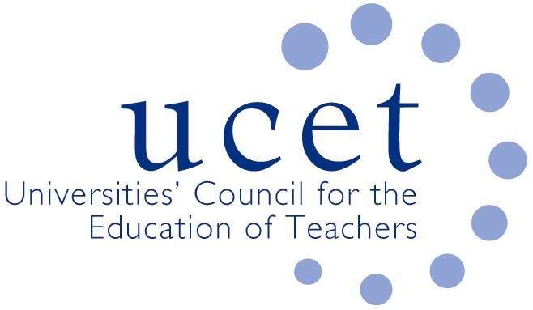
A Registered Charity (No 275082)

9-11 Endsleigh Gardens, London WC1H 0EH

E: info@ucet.ac.uk

Promoting Quality in Teacher Education

COVID 19: SUGGESTED MODEL FOR ITE STRUCTURES IN NORTHERN IRELAND 2020/21

Introduction

This paper sets out an exemplar of how ITE providers in Northern Ireland might review and adjust their undergraduate and postgraduate ITE programmes to respond to the challenges presented by the Covid 19 pandemic, particularly in respect of school placements and the implications of social distancing regulations.

The context of this paper has been informed by current institutional plans by the four HEI providers in Northern Ireland. It should be interpreted flexibly according to the needs and context of each provider.

The role of regulatory authorities

The challenges presented by Covid 19 in relation to teacher education cannot be met by HEIs and schools alone. Regulatory agencies such as the Department for Education, GTCNI and ETI also have a role to play, through for example:

- Reminding schools of the contribution that student teachers can make to the work of schools, particularly during the current crisis. Student teachers will be developing unique skills in regard to blended and on-line learning which could be of invaluable use in a school setting. Student teachers should not however be treated merely as an ‘extra pair of hands’, and will have to be engaged in meaningful learning opportunities.
- Establishing a Covid 19 strategy team consisting of government departments, GTCNI, ETI, UCETNI and school principals to plan and oversee the response to Covid 19 in the ITE sector.
- Providing clarification of the status of student teachers in schools, including if possible the granting of ‘key-worker’ status.
- Reviewing regulatory requirements, particularly those relating to the number of days student teachers spend in school, other school experience expectations and assessment criteria relating to the core competencies (e.g. 17, and 20-26).
- Recognising that engagement with schools can take place remotely as well as being ‘on-premises’.
- Facilitating regular communications and discussions with ITE providers, UCETNI and other relevant bodies.

ITE programme structures and organisation

(a): Management and oversight

ITE providers should establish a central management team to develop, implement, monitor and regularly review plans in relation to Covid 19 within their institution. This group should liaise directly with senior managers and those responsible for teaching programmes, and be ready to provide immediate advice and recommendations a short notice.

(b): Centre (HEI) based programme delivery

ITE providers are committed to using more on-line delivery and blended learning approaches, particularly at the beginning of the first semester. This should include opportunities for whole-cohort discussions between staff and students, interactions between groups of students, one to one sessions between tutors and students and smaller scale student discussions, including those of a social nature. Programmes can be taught in both synchronous and asynchronous ways. The content of programmes will be adjusted to ensure that students learn about how to deliver quality on-line and remote learning to pupils in schools. ITE providers should investigate how support, mentoring and coaching can be provided on line.

Some face to face teaching and learning can, subject to social distancing rules, also take place. This may involve sessions being run several times to smaller than usual groups of students.

(c): School experience

ITE providers should stay in regular communication with schools, and be willing to adapt placements and be responsive to the changing needs and priorities of schools. Schools should be seen as full partners in the design and delivery of ITE, and the opportunity to forge stronger partnerships should not be lost. University expertise and advice in terms of remote learning, social distancing etc. should where possible and appropriate be made available to school partners.

Consideration might be given to delaying block school experience that would have taken place at the beginning of programmes for undergraduates in the first few years of their training who will have more opportunity to go back into school, although it is recognised that this might not be possible for postgraduates. Orientation sessions of just a few days to allow students to familiarise themselves with school life might however be undertaken early-on. HEIs will respond in flexible and creative was to the regulations, for example where possible by splitting bock school experience and interspersing them with on line or face to face centre-based work.

Robust risk-assessments should be carried out, in consultation with schools, to ensure the health, safety and mental well-being of students in school and tutors visiting (if required) students on school experience. Consideration will have to be given to how students can travel to schools in a way that protects them and the pupils and staff in the school.

Conclusion

This guidance will be kept under review and amended in the light of changing circumstances. We are grateful to all those who contributed to its production.

UCETNI
June 2020

June 2020

