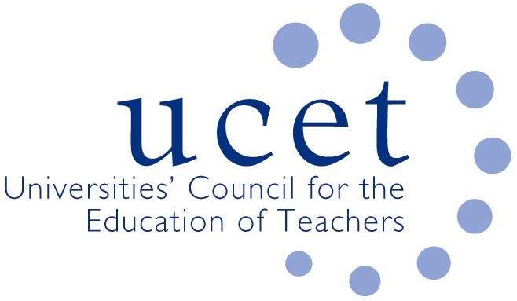

UCET Teacher Education consultative group: terms of reference

Purpose of group

The purpose of the group is to consider the purpose, content, structure and delivery of initial teacher education over the next 3-5 years (2020-25). It will consider the strategic, environmental and policy issues that will impact on the recruitment, education and ongoing professional development of teachers in the years ahead and The group will have a UK wide focus and will give relevant parts of the education sector the opportunity to lead the debate around teacher education in a way that is not constrained by the regulatory and policy environment.

The group will, amongst other things, consider: the content, structure and organisation of teacher education; the nature of partnerships; the links between ITE and CPD; and recruitment. The aim of the group will be to reach a professional consensus on each of the issues and to inform both policy and practice.

Membership

Membership of the group will consist of representatives from the following organisations:

- Universities Council for the Education of Teachers (UCET)
- Association of School and College Leaders (ASCL)
- British Educational Research Association (BERA)
- Council for Subject Associations (CfSA)
- Delta Trust
- [Scottish Council of Deans of Education]
- National Association of School Based Teacher Trainers (NASBTT)
- National Association of School and Union of Women Teachers (NASUWT)
- [National Education Union (NEU)]
- Teach First
- Universities and Schools Council for the Education of Teachers Cymru (USCET)
- Universities Council for the Education of Teachers Northern Ireland (UCETNI)

Other organisations will be invited to join the group as and when necessary.

Meetings

There will be one initial meeting in September 2020. The secretariat will be provided by UCET.

UCET
July 2020

