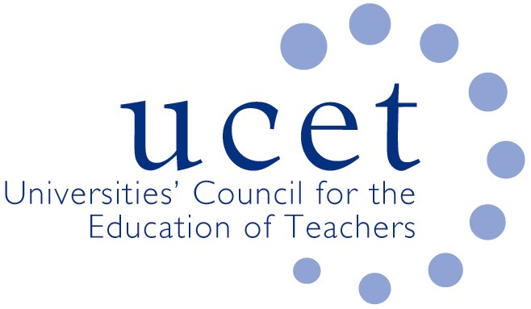
A Registered Charity (No 275082)

9-11 Endsleigh Gardens, London WC1H 0EH

T: 020 7621 6836
info@ucet.ac.uk

Promoting Quality in Teacher Education

14 July 2020

Dale Heaney
Tackling Educational Disadvantage
Department for Education
Rathgael House
Rathgill
Bangor
Northern Ireland BT19 7PR

Dear Dale,

Thank you for your letter of 8 July about the Engage programme and the potential for ITE students to contribute to its work. I know that individual UCET NI member institutions will be submitting their own comments on the proposal.

UCET NI welcomes the proposal, and agrees that ITE students (particularly those on undergraduate programmes) could play a useful role, provided of course that it involves them having access to valuable learning activities and does not distract from the core purpose of their teacher education. We look forward to working with you to take forward the practicalities.

Yours sincerely,



James Noble-Rogers
Executive Director

