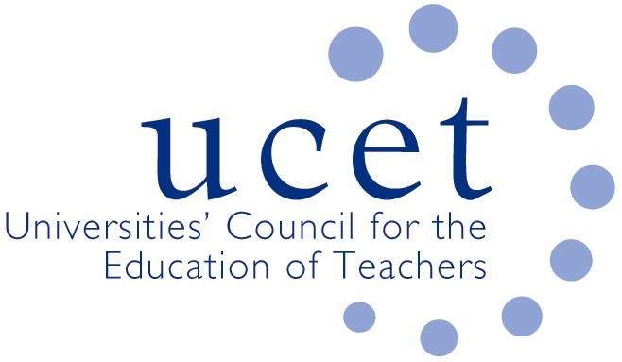
A Registered Charity (No 275082)

Promoting Quality in Teacher Education

Minutes of the meeting of the School Reference Group held at 1pm on Wednesday 3 June February 2020 via Zoom

Present

Chris Buckley (YITSA)
Sean Cavan (Sheffield Hallam University, & UCET Chair)
Julie Greer (Cherbourg Academy, and SRG Chair)
Jan Linsey (East SIL, John Jamieson)
Nicola Lyons (Minster School TSA)
Jackie Moses (UCET)
Margaret Mullholland (ASKLL)
James Noble-Rogers (UCET)
Keith Perera (Inspire & Bosco teaching school alliances)
Brian Rock, Ebor Hope TSA
Samantha Summerfield (Keele & North Staffordshire SCITT)

Welcome & introductions

- Colleagues were welcomed to the meeting.

Minutes of the previous meeting

- The minutes of the meeting held on 26 February were agreed. On matters arising, the SEND round-table event had taken place and would feed into a session at the annual UCET conference. The establishment of new teaching school hubs had been delayed by a year and existing hubs would continue to receive funding for that period. Concern remained however that the withdrawal of teaching school status for some schools would impact negatively on their ability to maintain ITE provision and support school-direct partnerships, with resulting implications for teacher recruitment, particularly in rural, coastal and other disadvantaged areas. It was hoped that the delay could allow time for the new criteria to be adjusted to help support the existing infrastructure.

Covid 19 related issues

- As a result of negotiations between UCET, NASBTT and DfE, ITE providers were able to recommend for QTS 2019/20 trainees who were considered to be on a clear trajectory towards meeting the teacher standards before school placements had been curtailed, provided that they continued with their ITE programmes (albeit outside school). DfE had also relaxed the ITE criteria for 2019/20 in regards time spent in school, consecutive age-phase placement experiences; the two-school requirement; and the ‘wholly or mainly’ in England requirement. For recruitment in 2020/21, flexibilities had been made in regards interviews taking place on-line, and a new 30 November deadline for applicants to demonstrate that they meet the GCSE entry requirements. UCET was pressing DfE for decisions on: a continuation of ITE requirements into 2020/21 (the days in school flexibility would continue); and the provision of financial and other support of students not on a QTS trajectory who might have to repeat placement experiences next year. UCET had also pressed for the introduction of the ITE core content framework and the new OfSTED inspection framework to be delayed to allow ITE providers and schools to focus on new priorities.

- SRG members reported that ITE programmes had continued after lockdown through, for example: Zoom sessions; mentor’s assessing students against each of the teacher standards and developing bespoke training activities, as well as engaging with research. Some concern was expressed about inconsistent approaches being adopted by different ITE providers. On current trainees continuing to go into school, UCET had advised that this could be done provided that all parties were in agreement and the safety of students and staff ensured.
ITE recruitment for 2020/21

- Applications to ITE programmes for 2020/21 were reported to be healthier than for many years, although the scope to actually recruit might be hindered by the lack of placement opportunities, which is why continued relaxation of the ITE requirements was thought to be essential. Engagement for potential applicants with schools and providers were taking place on-line. There had been some examples of applicants deferring entry to 2021/22 because of the current situation.
- The group discussed the importance of schools taking account of the benefits as well as the challenges of engaging with ITE, and it was agreed that SRG members should be invited to take part in discussions which would identify and promote these benefits, provided of course that trainees were not simply an extra pair of hands but engaged in meaningful learning.

ECF update

- No announcements had been made regarding the Early Career Framework in the light of Covid 19. It was however thought likely to go ahead in the pilot regions, with the possibility of some flexibility to allow the unique needs of this year’s NQT cohort to be met. Some ECF resources might be available to non-pilot areas. Resources from the Chartered College had, it was noted, already been circulated.

Items for information
- SRG members noted: the UCET response to the draft OfSTED inspection framework; details of the 3-4 November on-line UCET conference; the draft UCET strategy for 2020-2025; and the Easter UCET newsletter.

Any other business

- Julie Greer was thanked for her excellent service as Chair of the SRG for the last five years. Nominations for a new Chair, who would also serve on the UCET Executive, would be invited soon.

Date of next meeting

14 October 2020, via Zoom.

