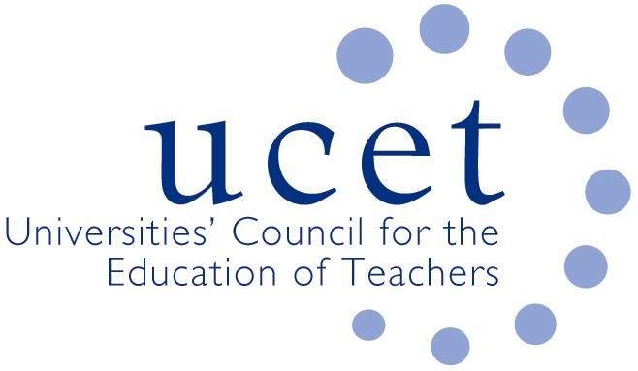
A Registered Charity (No 275082)

Promoting Quality in Teacher Education

Note of the meeting of the ITE secondary forum held at 1pm on Tuesday 10 March 2020 at Mary Sumner House, Tufton Street, Westminster, London SW1P 3RB

Welcome, introduction & minutes

Colleagues were welcomed to the meeting. The note of the previous meeting held on 26 November 2019 was agreed. On matters arising, JNR reported that UCET was keeping a close eye on the DfE’s shape of the ITE market review and inputting into DfE discussions.

Discussion

Highlights from the afternoon’s discussions included:

- The implications for ITE of the Corona virus, where skype interviews and interviews at alternative locations were being considered. Where necessary, student-teachers in isolation might be given alternative QTS related work to do. Securing alternative placements for students who might have been in contact with the virus could prove difficult.
- An update from JNR on: bursaries for post-compulsory student teachers; the early career framework (and lack of school preparedness); the 2020 UCET conference; and developments in Northern Ireland and Wales.
- UCET’s draft response to the OfSTED ITE inspection framework, with key points including: the unrealistic and undesirable (e.g. in terms of recruitment) expectations in regards consistency across partnerships; the importance of student teachers being able to engage critically with research, including that underpinning the core content framework; and the inappropriate prohibition of teaching and critiquing approaches to early reading in addition to systematic synthetic phonics. Comments and suggestions included: a lack of detail in the grade descriptors about what OfSTED expect to see as evidence on the impact of ITE curricula; the focus in OfSTED consultation meetings of giving information rather than seeking feedback; lack of clarity about when inspections actually begin; unrealistic expectations on providers to ‘report’ apparent failings of partner schools; and the desirability of schools being expected to offer placement opportunities.
- Reports from OfSTED pilot inspections, including focus on: mentors’ knowledge of the core content framework; sequencing; the welfare of student teachers; the contrasting nature of partner schools; and the extent to which students in London were made aware of the needs of schools and pupils in coastal areas.
- It was agreed that the next symposium would have a research focus related to ITE content, with possible suggestions from the Bristol science project and the IBTA group.
- The report from the Intellectual Base of Teacher Education group and the development of a new UCET strategy.
- The ITE core content framework; with examples given of how providers are mapping the centre and school-based programmes against CCF expectations, and the importance of ITE providers being able to engage critically with the CCF and its underpinning research.
- Recruitment to ITE, with applications nationally lower than at the same time last year, although the ratio of acceptances to applications were slightly up. Applications were no longer expected to peak before January, and DfE would be having marketing drives at four points in the year, including early summer. A shift from School Direct to core was reported in some cases, possibly reflecting imminent changes in regard teaching school hubs and the possibility that the market for SD students had been exhausted. Specific feedback included: Art & Design and business studies up because of bursary changes; geography and MFL struggling; and English and RE OK. The difficulties of students not receiving bursaries, in terms of their mental health & retention, was discussed, and the impact on retention of changes in regards prior school experience reaffirmed. Schools were also reported as being increasingly reluctant to accept students with any particular needs or characteristics.
- The new Apply Service, and the risks of having two systems running in parallel and the ICT issues facing HEIs and the new apply system.
- SKE, and recent decisions allowing students to select their SKE provider, with lack of clarity whether the ITE provider can require it to be face to face or remote provision. It was reported that 84% of SKE students in the last two years undertook on-line provision with just 68 people on longer face to face programmes of 24 weeks or more. Retention rates of SKE students on ITE, possibly because of this, were now no longer greater than those not coming through SKE. The different rules relating to Teach First and SKE were also noted and discussed.

Items for information

The following were noted for information: details of the 2020 ICET conference, and the December 2019 UCET newsletter.
Date of next meeting

Tuesday 16 June 2020.

