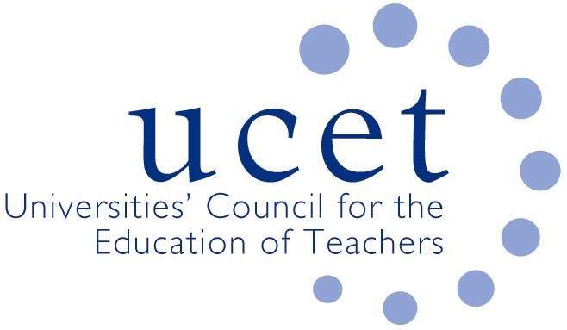

SUPPLEMENTARY GUIDANCE ON COVID 19 AND PCET ITE PROGRAMMES
We note that the ETF document relating to incomplete FE ITE programmes in the light of the Covid- 19 situation has occasioned some concern amongst members. There is a balance to be struck between assuring the quality of those that complete the programme and meeting the ongoing needs of the sector.
Therefore, we are seeking to clarify the position from UCET’s perspective. The guidance is primarily aimed at, but not limited to, Pre-service and In-service trainees expecting to complete in the Summer of 2020. The document from ETF is a general set of recommendations to the sector, covering HEIs and Awarding Bodies, and sets a desirable minimum completion level for the Diploma in Education and Training regarding teaching practice and observations during the current crisis. Trainees that meet the minimum completion level can be awarded credit and awards and should be provided with an action plan to take forward into their first year of teaching. It is recognised that in some cases, meeting these minimum levels will not have been possible and so alternative decisions at a local level will need and can be made. The Chair and Vice Chair of the post 16 committee have had discussions with ETF and are in a position to give additional advice to any HEI to which this applies. It is important to note that ETF provide only good practice recommendations and the final decision always rests with the HEI as the awarding organisation.

UCET
March 2020

