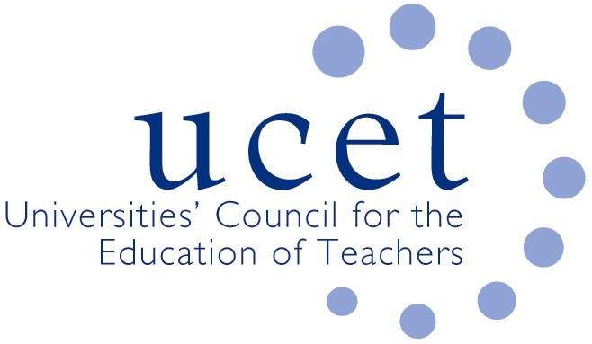
A Registered Charity (No 275082)

9-11 Endsleigh Gardens, London WC1H 0EH

T: 020 7621 6836
info@ucet.ac.uk

Promoting Quality in Teacher Education

Note of the meeting of the UCET Research & International Forum held at 1pm on Tuesday 21 January 2020 at Mary Sumner House, Westminster, London SW1P 3RB

Welcome, introductions and note of the previous meeting

Forum colleagues were welcomed to the meeting. The note of the meeting held on 8 November 2019 was approved. On matters arising, Birmingham City University reported that it had taken part in discussions with the Commonwealth Education Trust.

Discussions:

Forum members discussed a range of issues linked to the meeting agenda, including:

- UCET updates, including the noting with sadness of the death just before Christmas of former UCET Executive Director Mary Russell MBE. Other updates related to: the imminent launch of the consultation on the new OfSTED ITE inspection framework; the DfE review of the ITE market; the Early Career Framework pilots; a forthcoming UCET round-table on SEND and ITE; and developments in other parts of the UK.
- Feedback from the morning symposium, which had been led by Mark Boylan from Sheffield Hallam University and had covered the maintenance of research cultures by accessing various sources of research funding. Points made during the discussion included: the scope to bring together information exchange and research; the evolution of more strategic relationships within institutions between teacher education and education research; staff contract issues; the proportion of teacher education staff holding, or working towards, doctorate qualifications; the time allowed for staff to engage in research; cross-institutional collaboration; building international research profiles; co-writing of research; the balance between directing and encouraging staff to engage with research; and the role and work of the International Professional Development Association (IPDA). It was agreed that the topic for the next symposium would be:’ Brexit and International issues’, with the KEF as a possible topic for a subsequent event.
- The Research Excellence Framework, including the presentation of slides prepared by Tanya Ovenden Hope. Comments made in respect of the REF included: although proportionately small across the sector, a number of institutions did have a large number of 4* impact studies; differences between institutional level and REF judgements of research quality might be overstated; requests for small unit exemptions were not always straightforward; in some subject areas (not education) institutional submissions were nearly complete; institutions were modelling various scenarios on different assumptions; staff leaving institutions could impact on the metrics in terms of numbers of submissions made; account should be taken of intellectual identities when deciding on which outputs to submit; and EdD research students could be recognised in data (if properly coded) and in environment statements.
- Institutional updates and horizon scanning, covering: the BERA survey of research in regards teacher education taking place in schools - https://www.surveymonkey.co.uk/r/QP937LM -; reports that planned DfE research activity might be curtailed; and continued lobbying by UCET and others for a reinstatement of funding for SCoTENs by the relevant Northern Ireland government departments. .
- The publication of the second phase of OFSTED’s research into the ITE curriculum, which included some positive references to research (notwithstanding ambiguous references to ‘out of date’ theories).
- The continuing work of the IBTE group and the development of the new UCET strategy.
- A request for case studies to include in the UCET Building Research Informed Teacher Education Communities paper.
- The BERA blog, including a presentation and an encouragement to contribute from Gerry Czerniawski (g.czerniawski@uel.ac.uk).
- The new ITE content framework which will apply to all QTS programmes from September 2020, and which is intended to allow flexibility and an appropriately critical approach.
- The research report into the Digital skills of primary school teachers in Northern Ireland which had been funded through UCETNI and carried out by colleagues from Ulster University.
- International activities, including a new InfoTed survey into the professional development of teacher educators in different countries; the forthcoming ICET conference at Bath Spa University; and the invitation to submit applications for UCET travel scholarships.

Date of next meeting

12 May 2020

Date of next meeting

21 January 2021

