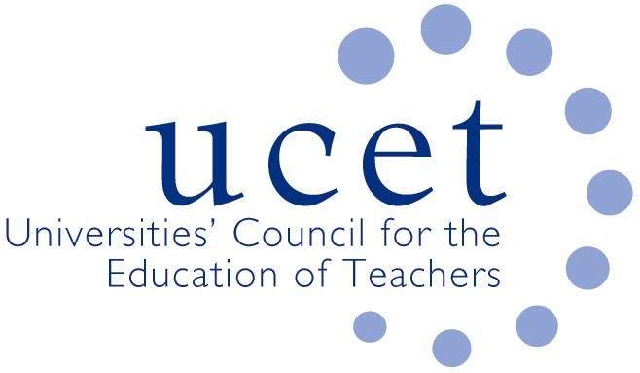
A Registered Charity (No 275082)

Promoting Quality in Teacher Education

Minutes of the meeting of the UCET Northern Ireland Committee held at 10am on Tuesday 14 January 2020 at the Open University, 110 Victoria Street, Belfast BT1 3GN

Present

Linda Clarke (Ulster University)
Martin Hagan (St. Mary’s University College)
Anne Heaslett (Stranmillis University College, Vice Chair)
Roisin McPhilemy (Open University, Chair)
James Nelson (Queen’s University)
James Noble-Rogers (UCET)

Apologies

Carl Bagley, Fiona Henry, Jackie Moses.

Minutes& matters arising

The minutes of the meeting held on 1 October were (subject to typos) agreed. On matters arising:

- Invitations for 2020 UCET travel scholarships had been invited in the previous week’s UCET bulletin.
- Volunteers were invited to represent UCET NI on the communications and engagement sub-group of the Learning Leaders Working Group. In the meantime, the UCET NI Chair and/or JNR would represent the committee. The draft remit for the group is attached as an annex. Volunteers should contact JNR.

Institutional updates

These included:

- Several institutions were preparing for imminent ETI inspections
- The Open University had re-entered the ITE market in Wales.
- Queen’s University had appointed a new Director of Postgraduate Studies.

Matters from the Chair

Matters from the Chair included:

- With the reconvening of the NI Assembly, the attention of new education ministers was likely to focus on schools, although ITE had been identified as one area of potential review, although it was pointed out that logically any such review ought to encompass teacher education as a whole as well as ITE. It was agreed that JNR would write to the new minister congratulating him on his reappointment, and requesting a meeting to discuss various issues including: ITE allocations and infrastructure; funding for SCoTENs; EPD pilots on the context of the ECF in England; and the planned 19 May event at Stormont.
- ITE allocations, were it was agreed that UCETNI would again press for allocations covering a 2-3 year period, pointing out that government departments were themselves moving towards a 3-year planning cycle.

Digiskills launch

The research into the digital skills of primary school teachers in Northern Ireland carried out by Ulster University and funded through UCET NI was due to be launched that week, with the new minister in attendance. Requests to carry out comparable research into secondary and SEND schools would be made.

Developments elsewhere in the UK

JNR provided an update on issues including: The ITE content framework in England; the Early Career Framework; the development of National Professional Qualifications (NPQs) for serving teachers; and a new OfSTED ITE inspection framework. A report was also given on the development of a new UCET strategy and the work of the Intellectual Base of Teacher Education Group.

19 May event

The main focus of the meeting was on planning the event to be hosted by UCETNI on the morning of 19 May at Stormont, with invitees including MLAs and colleagues from the government departments, Education Authority, GTCNI, ETI and the media. It was agreed that the event would highlight the contribution that teacher education makes to the economy and wider society of Northern Ireland. Teacher education programmes equipped people with skills identified as being in deficit in the previous year’s skills audit report (Northern Ireland Skills Barometer Summary report, July 2019), as well as with a range of interpersonal skills and qualities, all of which make a valuable contribution to life in Northern Ireland. Crude assumptions that teacher education is only worthwhile to the extent that it supplies teachers to schools should be countered, and the fact that so many high quality people want to go into teaching should be celebrated rather than discouraged. The event should draw on the work of the IBTE group and the qualities that go to make up effective teachers.

A working title for the day might be: ‘The contribution of teacher education to Northern Ireland’s economy and society’. An additional meeting of UCET NI would be held on 4 March to agree the final arrangements. One possible programme, for further refinement, might be:

- 9.45am: Arrival and refreshments
- 10.15am: Welcome from UCET NI Chair/Executive Director
- 10.15-10.30am: Welcome from Minister (tbc)
- 10.30am-10.45am: Headteacher perspective on the contribution and quality of ITE and CPD provided by HEIs in Northern Ireland
- 10.45am-12.00: Panel session, with a representative from each institution speaking for 10 minutes on the contribution they make to a specific aspect of Northern Ireland’s economy and society (e.g. the economy, skills gaps; widening participation, social cohesion; lifelong learning, subject knowledge, research, teacher supply etc.), followed by questions from the floor.
- 12.00-12.30pm: The intellectual base of teacher education, the unique contribution of the HE sector and the qualities that all teachers need.
- 12.30-1.00pm: Buffet lunch & networking.

The event will be followed by a presentation from IPDA on the establishment of IPDA NI, where it was felt that an IPDA group distinct from that for the Republic would be advantageous. Registering for the annual IPDA conference at a cost of circa £350 conferred membership and a minimum number of members from NI (which might include JNR) would be required to form a new group.

Each UCET NI member institution, IPDA, TEAN, SCoTENs and others would be invited to have stands.

Any other business

None

Date of next meeting

5 May 2020 (with event planning meeting on 4 March).

Annex

Communications and Engagement Sub Group

Aims and Objectives

- Agree and keep under review a Communication Plan.
- Ensure effective and consistent communication between stakeholders and between stakeholders and the wider education profession, including teachers, in relation to Learning Leaders.
- Review, agree and monitor communication methods, mechanisms and performance.
- Establish roles and responsibilities of each organisation represented on the Oversight Group.
- Establish protocols and processes for collaborative working between organisations.

The Role of the Group

- Collect evidence to enable communications to be reviewed and improved.
- Ensure delivery of high quality communications.
- Monitor the impact of communications.
- Report on communication activities to the Oversight Group.
- Promote Learning Leaders.
- Identify opportunities for communication activities.
- Participate in communication activities, including best practice seminars and conferences.
- Provide advice on development of electronic communications activities.
- Ensure that all communication with the education sector relating to Learning Leaders is consistent.

