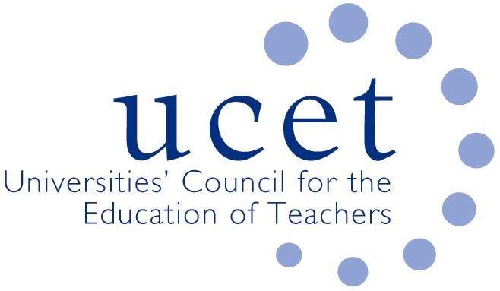
A Registered Charity (No 275082)

9-11 Endsleigh Gardens, London WC1H 0EH

E: info@ucet.ac.uk

Promoting Quality in Teacher Education

CPD adjustments in the light of the Covid 19 pandemic

Institution 1

- All teaching is now online (through Blackboard) with either live or recorded academic input
- All assessment will now be through Blackboard (as was the case for most modules anyway)
- Blanket 2-week extension for all PG dissertations. However, due to all face to face data collection being suspended by the University it means some students are half way through an empirical study and are finding completion difficult. We had been looking to give them technical extenuating circumstance (TEC) but now we are looking at changing deadlines so not to disadvantage students. This is more wide ranging then data collection as students could be ill, may be in self isolation, may have children at home now with schools closed or may have to provide for elderly self-isolating relatives.
- If changes are substantial to the delivery or assessment of modules we are making validation style modifications to modules. These are still having to be agreed by external examiners but are being signed off at Department level rather than University level.
- Not applicable to CPD but all exams are now open book and timed online or a different assessment method used.

Institution 2

Two courses we wrote for FutureLearn on Supporting Successful Learning in Primary and Secondary Schools are open at the moment and we could extend that opening.
Although we marketed them at Support staff, anyone would benefit as they cover ones’ own values, beliefs etc, how children learn, the environment for learning including behaviour management and communication and language.
They feature two schools round here.

https://www.futurelearn.com/courses/supporting-learning-primary
https://www.futurelearn.com/courses/supporting-learning-secondary

Its 3 hours per week for 4 weeks but they can also be completed in a day or less.

We are likely to use them as additional materials for trainees at xxxx.

Institution 3

MA Education (90 participants). The MA is the completion phase of the PGDipEd. A one year programme, taught sessions were completed in the Autumn term. Most collect their data either just before Christmas or mostly in the Spring term. A few weeks ago, I advised all to adapt if necessary, but to ensure that they completed their interventions/data collection. More recently, with the announcement of schools to close, issued guidance about how they could adapt their data collection if it had not been completed. Our University guidance is allowing us to be creative in how we manage this and so far it is working as well as can be expected. The key thing is, they want as many to submit in September as possible (they are not changing the submission date) and we are not allowed to give ’blanket’ extensions or LoA, as we could end up with unmanageable workloads next year.

Institution 4

Currently deadlines are considered but we have not had clarity yet on whether it might be moved. Students are asked to use the usual channels to apply for mitigating circumstances to be considered. Regarding assignments, for MA assignments the issue is data collection for their research projects. We had to rethink that for shorter pieces as well as dissertations and had to look at redesigning the tasks in some cases to accommodate for the circumstances students find themselves in.

Institution 5

Main campuses closed on Friday 20th March and the whole university moved to online teaching and supervision from Monday 23rd March. Within the Faculty of Education, our Directors of Quality, Programmes and Learning & Teaching worked intensively with Programme Directors one-to-one, to ensure that all was in place for this. The first focus of attention was the ITE placement issues where everything changed very rapidly. Meanwhile many postgraduate programmes (MA and PGCert) - with less frequent teaching sessions than undergraduate programmes and with many part time students - had already been moving online to reduce travelling and face to face contact, by mutual arrangement between tutors and students. Programme teams have collaborated to produce guides to take students through existing online resources and materials, within the overall guidance from the university to keep things simple and straightforward and focus on student support rather than trying to create perfect online programmes overnight. Much of the postgraduate teaching had already finished for this Trimester so that students could easily be supported remotely for their assignments using email, Skype, Blackboard Collaborate etc. Training has been offered to support this, with staff directed to online guidance and support as well as sessions in real time accessed from home. MS Teams is being used for meetings between colleagues, facilitated by peer support.

The library buildings closed on Tuesday 24th March. Remaining library budgets have been reallocated to online resources only and staff have been reminded to spend their allocation to ensure programmes are well resourced for remote library access.

New policies governing assessment have been published centrally by the university and communicated to students. The main principles applying to postgraduate (CPD) programmes are to
- keep to set assessment deadlines and timescales as far as possible
- provide slightly more leeway on the penalties for late assignments
- relax the need for evidence to support self-certification of extension requests (aligning with guidance from the Office of the Independent Adjudicator for HE)
- extend extenuating circumstances timelines if studies are disrupted by illness or circumstance (e.g. longer period of self-certification allowed)
- ensure student progression is meticulously tracked where there may be more delays and extensions than normal
- simplify processes and forms and minimise administrative actions
Many of our students are in the middle of action research or practitioner research assignments, including dissertations. All face to face research was required to cease with immediate effect. Transition to online research is recommended, alternatively shifting to desk-based research. The bureaucracy for ethical approval of amendments has been minimised – a direct shift to doing the same data collection by virtual means rather than face to face, where the project has already been given approval, does not require extra approval for the amendment and students are given advice to amend information and consent documentation accordingly and are trusted to do so. Many practitioners are still working with students and colleagues virtually and can amend their research according to the new circumstances. A simple template has been issued for adjusting assignments only where necessary, still meeting the learning outcomes and avoiding changes to the structural set-up in student records. The Faculty Director of Learning and Teaching has worked directly with Programme Directors to ensure students are sent comprehensive guidance on their assignments where adjustments have had to be made. Interruptions to timescales are to be avoided. The main principle is that it is better to adjust the research within the new parameters, than to request interruption so as to be able to keep to the original plan. It is thought that examinations, including vivas, will take place virtually.

Now turning our attention to the implications for professional qualifications and assessments e.g. the National Award for SEN Co-ordination, British Dyslexia Association where I understand guidance is just coming out.

Institution 6

On our MA courses, and the SENCO qualification, we have taken the following steps for now:
- For the SENCO qualification, we have looked to add 6 months to the deadline for research based assignments, to give them proper time to do this work, if/when schools are up and running again. Some are of course choosing to focus research / student assessment on movements to online provision for children, but this likely will not be possible for all.
- Where research is involved at M level, the expectations for significant in depth data collection and analysis are proving troublesome, and we are still looking at options. Some students will have collected data, and some will be able to collect data remotely. For others, extensions might need to be applied for.
- More generally, blanket 2 week extensions have been added to all assignments, and all presentations have been recalibrated, so that they can be done online.

UCET
April 2020

