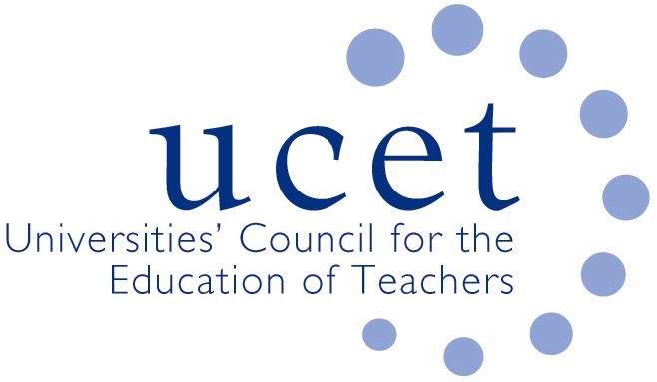
A Registered Charity (No 275082)

9-11 Endsleigh Gardens, London WC1H 0EH

T: 020 7621 6836
info@ucet.ac.uk

Promoting Quality in Teacher Education

UCET Intellectual Basis of Teacher Education (IBTE) position paper

Preamble
In January 2019 a UCET working group was established to consider the values and principles that underpin our work as teacher educators working in universities across the United Kingdom. One purpose of the work has been to inform the development of the next UCET Strategy and to provide the opportunity for further debate within the organisation about these core values and principles. The group was also set up to complement the work of a previous UCET working group that resulted in the publication of the Research Informed Teacher Education document. The IBTE group has met on five occasions. A draft document was produced in September 2019, which was subsequently discussed at Executive Committee and the various UCET forums, as well as being the focus of a session at the annual conference in November 2019. Feedback from these discussions led to revisions, with the final version of the document being published in January 2020.

The IBTE position paper goes beyond being a ‘vision statement’ and is intended to be a document on which the officers and members of UCET can draw as appropriate. As a position paper it will be used to inform the next UCET strategy, in accordance with its original aim, but also used as the basis for any UCET response to policy consultations, government initiatives in relation to initial teacher education etc. Individual members might also wish to make use of it to inform discussions within their own institutions or wider networks across the UK.
The next stage of the work is to put together a robust evidence base to support the use of the position paper in any such responses.

UCET – the intellectual base of teacher education
UCET recognises that teaching is a challenging, complex, intellectual and ethical endeavour. Teaching is crucial in improving student learning and in enabling the positive, transformational contribution that education can make to communities, and to the development of more socially just and sustainable societies. It is these unique qualities that make teaching such an appealing profession.
This document sets out UCET’s vision for high quality teacher education that values teachers as intellectuals who take an enquiring stance to their work and make meaningful contributions to the professional knowledge base. To achieve this, it is imperative that all teacher education provision builds on the already substantial evidence base about teaching and teacher education. High quality teacher education draws on a corpus of knowledge embedded in ethical practice, including robust evidence from research, whilst accepting that knowledge is both contested and contestable. It encourages a lifelong commitment to the education profession and pays careful attention to the factors that promote a healthy learning environment for teachers and learners.
It is also important to recognise that high quality teaching flourishes within particular contexts that allow for mutually empowering professional relationships and collegiality. Teacher education can cultivate such collegiality through strong professional collaboration amongst all partners. Such collaboration is characterised by shared intellectual responsibility bringing together complementary forms of knowledge and experience. Thus, teacher education is a collective, co-constructed endeavour to which each partner brings unique forms of expertise and perspectives that are subject to change in an ongoing collaborative and dynamic process.
UCET values teacher education that works within a model of professional collaboration to produce teachers who are:
- competent and confident professionals who recognise and understand that educating is a professional, thoughtful and intellectual endeavour. They learn from research, direct experience, their peers and other sources of knowledge.
- epistemic agents, who act as independent thinkers, recognising that knowledge, policy and practice are contestable, provisional and contingent. As such, teachers search for theories and research that can underpin, challenge or illuminate their practice. They are able to analyse and interrogate evidence and arguments, drawing critically and self-critically from a wide range of evidence to make informed decisions in the course of their practice.
- able to engage in enquiry-rich practice and have a predisposition to be continually intellectually curious about their work with the capacity to be innovative, creative and receptive to new ideas emerging from their individual or collaborative practitioner enquiries.
- responsible professionals who embody high standards of professional ethics. They act with integrity and recognise the social responsibilities of education, working towards a socially just and sustainable world.
Universities are well placed to support the realisation of these characteristics. They offer space(s) to come together to think, reflect, critique, analyse and explore ideas and create new research. By so doing they provide a safe environment in which to ask challenging and open questions, provide reasoned solutions based on robust evidence, and to test the authenticity of their own claims and of those made by others. Furthermore, universities have a civic duty to extend and develop knowledge, without the constraints or limitations of imposed agendas or motives. It is precisely these responsibilities that give universities an inimitable role in teacher education that goes beyond the ‘training’ of teachers but sees teacher education as a multidisciplinary and collaborative field of inquiry, and a source of knowledge generation that fulfils a pressing and fundamental need in society. All of this leads to the development of a teaching profession that is able to shape the best quality education for all.

The IBTE group comprises Liz Atkins (Derby); Claire Brooks (UCL Institute of Education); Sean Cavan (Sheffield Hallam); Angella Cooze (Trinity St David’s); Cathy Gower (Brunel); Martin Hagan (St. Mary’s Belfast); Des Hewitt (Warwick); Divya Jindal-Snape (Dundee); Alex Kendal (Birmingham City); Linda laVelle (Bath Spa); Joanna McIntyre (Nottingham); Linzi McKerr (Worcester); Kevin Mattison (Birmingham City); Rick Millican (Gloucester); Jackie Moses (UCET); Lisa Murtagh (Manchester); Trevor Mutton (Oxford, IBTE chair); James Noble Rogers (UCET); John Thornby (Warwick); Alis Oancea (Oxford); Gillian Peiser (Liverpool John Moores); Elaine Sharpling (Wales, Trinity St David);

