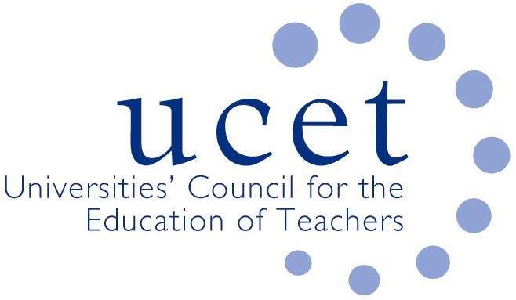
A Registered Charity (No 275082)

Promoting Quality in Teacher Education

Minutes of the meeting of the School Reference Group held at 1pm on Wednesday 26 February 2020 at Woburn House, Tavistock Square, London WC1H 9HQ

Present

Chris Buckley (YITSA)
Jake Capper, Archbishop Holgate School (Vice Chair, and Chair of meeting)
Spencer Hennessy (Emanuel College, Gateshead)
James Noble-Rogers (UCET)
Jackie Moses (UCET)
Brian Rock, Ebor Hope TSA

Welcome & introductions

- Colleagues were welcomed to the second meeting of 2019/20. Jake Capper was congratulated on his recent appointment as head teacher.

Minutes of the previous meeting

- The minutes of the meeting held on 16 October 2019 were agreed. On matters arising, concern was expressed that only direct mentoring under the ECF, not preparation time, would be centrally funded.

Updates

- The following updates were provided:

- UCET was in the process of developing a new strategic plan, which would be informed by the four key characteristics of properly educated teachers developed (amongst other things) by the Intellectual Base of Teacher Education (IBTA) group.
- The UCET December 2019 Christmas newsletter was noted.
Discussions
- UCET had convened a round table to discuss SEND in ITE issues. A resulting paper would be circulated in due course and discussed in detail at a subsequent meeting.
- The ITE core content framework (CCF) and OfSTED draft ITE inspection framework had both been published, with the CCF becoming mandatory for all ITE programmes from September 2020. SRG members were broadly content with the CCF, as much of it was covered in programmes already, provided OfSTED allowed scope for it to be addressed with appropriate academic rigor. Concern was expressed about the prohibition in the draft inspection framework to assessing student teachers against the teacher standards part-way through programmes. ITE providers would, it was pointed out, need a way to ensure students were on the right trajectory, and there were fears that students might have legitimate grounds for complaint should they be assessed at the end of their programmes as not meeting the standards with no prior indication.

Teaching School Hubs

Although funding for existing teaching schools would be extended to September 2020/21 it is anticipated that this will be the final year of funding and that TS designations will end in August 2021, the key factor in approving new teaching school hubs would be specific eligibility criteria with the final determinant of outcome being progress, which meant that however effective some existing teaching schools were in regards existing KPIs, such factors would only be take into account when deciding whether to award TS status to schools with equal Progress scores, for secondary schools this would be from the Progress 8 measure. This could make it difficult for schools in challenging areas to secure TS status and might encourage ‘off-rolling’. The impact of the new hubs of existing SCITT and HEI provision (e.g. in terms of placement opportunities) was also noted.

Teacher education policy & recruitment

The following issues were discussed:

- Recruitment to both primary and secondary programmes remained challenging, with most colleagues reporting lower application figures than at the same stage in the previous year’s cycle. Location of school placements was reported as being a key factor in applicant choice. Examples of providing professional development opportunities to retain NQTs once qualified were given.
- The new Apply service, and the advantages of being an early-adopter’.
- Skills Test replacements, with all those present finding the new system as being less burdensome and less of a barrier to recruitment.
- Early Career framework pilots and pilot providers marketing their products in the pilot areas. Many head-teachers remained unaware of the full implications of the ECF. Confusion over the position of NQTs completing year one of the ECF in the pilot areas prior to national roll-out were noted.
- The DfE shape of the market review, which appeared to be focusing on the applicant journey rather than at fundamental issues relating to accreditation etc.

Any other business

An update was given on the development of new specialist NPQs for serving teachers.

Date of next meeting

3 June 2020 at 1pm. UCET chairs and vice chairs would be encouraged to attend. Suggestions for additional SRG members were invited.

