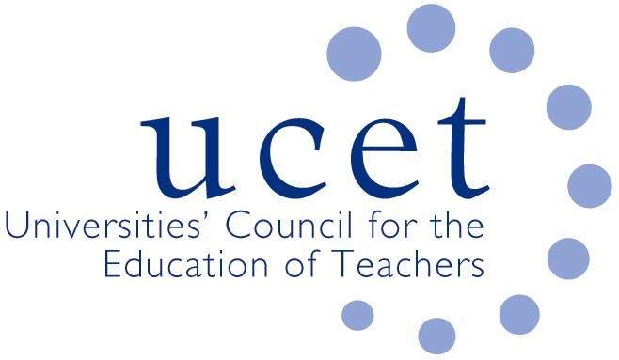
A Registered Charity (No 275082)

Promoting Quality in Teacher Education

Note of the meeting of the ITE secondary forum held at 1pm on Tuesday 26 November 2019 at Mary Sumner House, Tufton Street, Westminster, London SW1P 3RB

Welcome, introduction & minutes

Colleagues were welcomed to the first meeting of the academic year, and those attending for the first time introduced themselves. The note of the previous meeting held on 18 June was agreed.

Mary Russell

A moment’s reflection was held as a mark of respect for former UCET Executive Director Mary Russell MBE, who had recently died. Mary had been Executive Director since UCET’s inception in 1967 until she retired in 2004 and had made the organisation the influential force that it had become.

Discussion

Highlights from the afternoon’s discussions included:

- New arrangements to ensure fundamental skills in literacy & numeracy in place of pre-entry skills tests, with contributions to the discussion from Katie Chubb of DfE. Feedback as given on the arrangements providers were putting in place to comply with the new requirement. While some reported that this entailed more work for providers than skills test, others found the new arrangements to be less burdensome, and helped with recruitment. Examples of measures being taken included: formative maths tests carried out at interview; continued use of an already used diagnostic English test; assessing skills (e.g. through written assignments and data analysis) as part of normal ITE programme activity; use of existing DfE skills test examples; and mapping of programmes against maths and English requirements. OfSTED would it was reported monitor compliance by looking at the mechanisms in place rather than the assessment of individual students. Legacy issues affecting some 2,500 students whose QTS was contingent on passing the skills tests had still to be fully addressed. These people were being encouraged to take the tests as soon as possible, although Assessment Only (where placements while on ITE programmes could count towards the school experience requirements), might be on option for some. Removal of the skills tests might it was suggested lead to a further increase in late applications.
- An update from JNR on non-primary & early years related issues, including: developments in Wales and Northern Ireland; UCET’s support for member institutions in regards the REF; the results of Early Career Framework pilot tenders; and issues relating to student support for PCET ITE students.
- Topics for future morning symposia, where suggestions included: the ITE content framework & the new OfSTED inspection framework (potentially combined); mentor training and the development of teacher educators; and the evidence base for cognitive load theory.
- Recruitment and retention to ITE programmes; where later applications continued to be a trend, and the prevention of prior school experience requirements was leading to an increase in drop outs (although it was suggested that there might be a myriad of reasons why students without prior experience, who are often career changers, drop out). Retention rates were also being influenced by providers being encouraged to take greater risks with recruitment and because of the lack of financial support in some subjects. Securing placements in schools was also reported to be increasingly difficult because of pressures on schools. Specific feedback included: mixed picture in regards the balance between School Direct and core; lower recruitment to geography because of bursary reductions; history recruiting well; increases in business studies and art & design; science recruitment dominated by biology; and variable recruitment to computer science. As most biologists teach the range of science subjects, it was pointed out that funding second science SKEs would make a lot of sense and would help recruitment to the range of science subjects.
- The new ITE content framework, which would have to be reflected in all ITE programmes in England from September 2020. The framework should not be used as an assessment tool and did not cover everything that should be included on ITE programmes. UCET and NASBTT would be holding events to help members adjust their programmes, identify how aspects of the content framework were already being covered and change the way some things were done rather than impose wholly new burdens on providers. The framework was not endorsed by UCET, although was thought to have benefited from UCET representation on the advisory group. Examples of mapping and reviewing programmes in the light of the new framework were provided, although the various ways different aspects of programmes related to the framework could make this difficult, and might make it difficult for students to identify which parts of the framework had been addressed through which part of the programme. One institution reported trying to map the framework at three levels: development, consolidation and mastery. Other comments made included: the framework was too secondary focused; references to cognitive load were not future proof; and greater refinement in the light of comments made at round-table events could usefully have been made.
- Inspection issues, including feedback from OfSTED research visits, which had included a strong focus on behaviour management across all curriculum areas, core subject provision, consistency across all subjects and partner schools; and the strength of partnership arrangements.
- The development of a new UCET strategic plan for 2020 onwards and the work of the Intellectual Base of Teacher Education (IBTE) group.

Items for information

The following were noted for information: the UCET general election press release; the report of the 2019 ICET conference; and the summer 2019 UCET newsletter.
Any other business:

Reports were given of SKE compliance visits by DfE.

Date of next meeting

Tuesday 10 March 2020.

