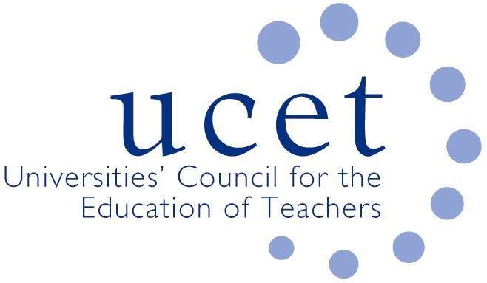
A Registered Charity (No 275082)

Promoting Quality in Teacher Education

Agenda for the meeting of the ITE primary & early years forum to be held at 1.00pm on Tuesday 3 March 2020 at Mary Sumner House, 24 Tufton Street, London SW1P 3RB

There will also be a morning symposium beginning at 10.30am on the draft OfSTED ITE inspection framework, with input from David Storrie and Helen Matthews from OfSTED. Invitations for the symposium have been issued separately. If you would like to attend but have not registered please contact Max Fincher at: m.fincher@ucet.ac.uk.

- Welcome and introductions
- Minutes of the previous meeting
- Matters arising
- UCET updates
- Inspection issues:
  - Feedback from morning symposium & draft ITE inspection framework
  - Reports from pilot inspections
  - OfSTED research findings
  - Grading of student teachers
  - Teaching of early reading/phonics
  - Other inspection issues
- Topics for future symposia
- ITE core content framework
- ITE recruitment:
  - Feedback from forum members
  - Apply service
  - Feedback on skills test replacements
- UCET strategy and the Intellectual Base of Teacher Education Group
- Early years:
  - Feedback from forum members
  - TATYC research
- Items for information:
  - 2020 ICET conference details
  - December 2019 UCET newsletter
- Any other business
- Date of next meeting: Tuesday 9 June 2020 at 12.30pm

Background papers

- Minutes of the previous meeting
- Draft ITE inspection framework
- OFSTED research summary
- ITE core content framework
- Nick Gibb letter on DfE apply service
- TATYC research report
- Final Intellectual base of Teacher Education Report
- 2020 ICET conference information
- December 2019 UCET newsletter

