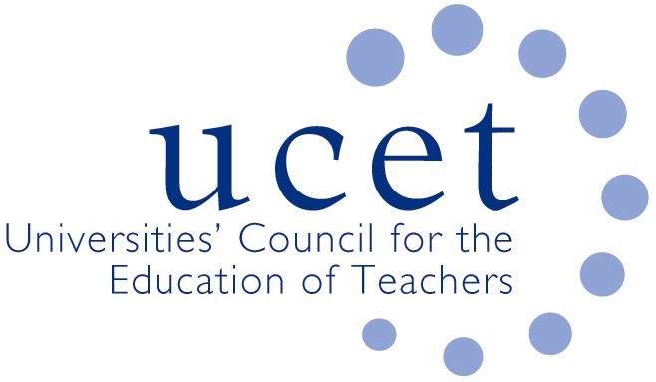
A Registered Charity (No 275082)

Promoting Quality in Teacher Education

Agenda for the meeting of the CPD Forum to be held at 1pm on Tuesday 11 February 2020 at Conference Hall, Mary Sumner House, 24 Tufton Street, SW1P 3RB

There will also be a morning symposium beginning at 10.15.am on National Professional Qualifications (NPQs) for serving teachers with colleagues from the DfE. If you would like to attend but have not registered please contact Max Fincher at: m.fincher@ucet.ac.uk.

- Welcome and introductions
- Minutes of the previous meeting (enc.)
- Matters arising
- UCET updates
- Morning symposia:
  - Feedback from morning symposium
  - Topics for future symposia
- Apprenticeships for serving teachers
- Delivery of M level CPD through distance learning
- Horizon scanning, institutional perspectives and strategies for dealing with internal pressures
- NFER Teacher Autonomy report (enc.)
- ECF engagement
- ITE content framework (encs.)
- IBTE group and the development of a new UCET strategy (enc.)
- Northern Ireland Digiskills report (enc.)
- International issues:
  - Feedback on recent international activities
  - 2020 ICET conference details (enc.)
  - 2020 UCET travel scholarship invitations (enc.)
- Items for information:
  - December UCET newsletter (enc.)
- AOB
- Date of next meeting: 2 June 2020

