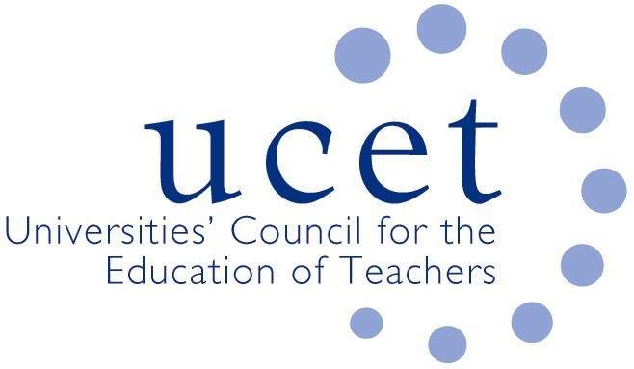
A Registered Charity (No 275082)

9-11 Endsleigh Gardens, London WC1H 0EH

T: 020 7621 6836
info@ucet.ac.uk

Promoting Quality in Teacher Education

15 January 2020

Peter Weir MLA
Department for Education
Rathgael House
Bangor
Northern Ireland BT19 7PR

Dear Minister

UNIVERSITIES COUNCIL FOR THE EDUCATION OF TEACHERS

I am writing to congratulate you on your re-appointment as Education Minister and to invite you to say a few words of introduction at an event UCET NI are holding at Stormont at 10am on 19 May 2020.

The 19 May event will give higher education institutions the opportunity to demonstrate to ministers, MLAs, officials and others the contribution they make to, not only teacher supply, but the wider economy and society in Northern Ireland. The event will include presentations from the HEIs involved in teacher education, input from head teachers and experts with UK wide and international profiles. We would be delighted f you could say a few words to welcome delegates to the event and listen to some of the discussions.

We would also welcome the opportunity to meet with you on a separate occasion to discuss a number of important policy issues, including: maintenance of the high quality teacher supply base in Northern Ireland; the contribution that HEIs can make to the professional development of teachers in the context of Learning Leaders, and the scope to reinstate funding for the highly important cross-border SCoTENs initiative. Please let us know if you are willing to meet and I will ask my office to arrange a suitable date.

Yours sincerely,

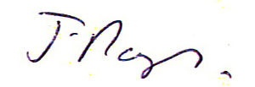

James Noble-Rogers
Executive Director

