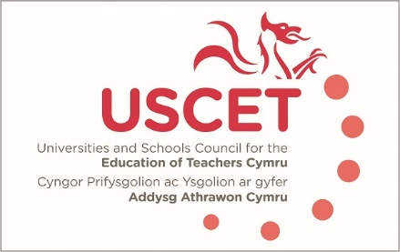

Agenda for the meeting of the University and Schools Council for the Education of Teachers (USCET) to be held at 10am on Thursday 30 January 2020 at the Media Resource Centre, Oxford Rd, Llandrindod Wells LD1 6AH

10.00am-11.15 am:
- Welcome & introduction
- Minutes & matters arising (enc.)
- Election of a new USCET chair
- USCET membership in light of terms of reference (enc.)
- USCET sub group membership (enc.)
- Teacher recruitment & retention advisory board (enc.)
- Updates from regional consortia and accredited providers
- ITE developments in other parts of the UK
- UCET Christmas 2019 newsletter (enc,)
11.15am-12.30pm:
Welsh Government, EWC, Qualification Wales and Estyn colleagues to join meeting
- Updates from:
  - Welsh Government (including ITE recruitment& financial incentives)
  - Estyn
  - Education Workforce Council
  - Qualifications Wales
- The future development of teacher education accreditation arrangements in Wales (Hazel Hagger)
- Assessment of teachers against the new professional standards
12.30-1.00pm: Lunch

Dare of next meeting: 21 May 2020

