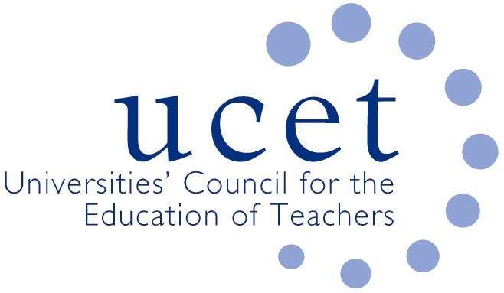
A Registered Charity (No 275082)

9-11 Endsleigh Gardens, London WC1H 0EH

T: 020 7621 6836
info@ucet.ac.uk

Promoting Quality in Teacher Education

Note of the meeting of the UCET Research & International Forum held at 1pm on Tuesday 8 November 2019 at Mary Sumner House, Westminster, London SW1P 3RB

Welcome, introductions and note of the previous meeting

Forum colleagues were welcomed to the meeting. The note of the meeting held on 14 May 2019 was approved. On matters arising, it was reported that: results of the ECF tenders would be announced soon; the ITE content advisory group had met several times, and early drafts of the content framework were being shared at round table meetings; OfSTED would consult on a new ITE inspection framework in the new year; and a follow-up was being planned to the May 2019 showcasing event in Northern Ireland.

Discussions:

Forum members discussed a range of issues linked to the meeting agenda, including:

- International issues, with a presentation from Eleanor Sykes on the work of the Commonwealth Education Institute, which provided on-line training & development for serving teachers in developing countries, with the aim of providing support for 150,000 teachers (reaching 6 million children) over the next five years. Reference was also made to the new IPDA journal ‘Practice’, which will feature regular features on global education, the report of the 2019 ICET conference in South Africa and a briefing on the 2020 ICET conference that will take place at Bath Spa University.
- UCET updates, covering : the establishment of a new group to consider consistent assessment against the new teachings standards in Wales; a recent event on partnership working in Wales; the development of a new UCET strategy for 2020-2025; and a UCET lifetime achievement award for Peter Gilroy
- REF issues, with feedback from the morning symposium on the drafting of environment statements where colleagues had looked at an example of a current draft statement for 2021 and examples of four-star statements from the previous round. Key points from the discussion included: statements needed to be clearly structured, with no unnecessary repetition; the impact of research and research income on end-users should be stressed; resources allocated to support for doctoral students could legitimately be included; and claims should be evidenced as they might be subject to subsequent audit. On other REF issues, the answers provided in response to questions raised at the last meeting were noted (although the extent to which output data could be used by more than one institution might require further clarification); there was a mixed picture on whether Head of Research and REF coordinator roles were held by the same person; and the difference between institutional and UOA specific environment statements in single UOA institutions needed to be clarified.
- It was agreed that the topic for the next morning symposium would be on the three topics of: Development and sustaining of research cultures through research income pipelines; Brexit and wider international issues; and Interrelationship between the REF, TEF and KEF
- Institutional updates, where: the implications of the centralisation and decentralisation of support services; student recruitment issues; the capacity of non-REF returnable staff to engage in scholarly activity; and the scope to take account of future research outputs when identifying staff with ‘significant responsibility for research’ were all noted.
- The agenda for the 5-6 November UCET conference, including a dedicated research strand, for which registration was still open at https://www.ucet.ac.uk/conference
- The paper from the Intellectual Base of Teacher Education Group, which had identified four key features of teaching that should be reflected in teacher education, and which built on the UCET ‘Building Research Informed Teacher Education Communities’ paper, which it was agreed should feature in a writing workshop for the production of case studies at the UCET conference.
- The report on professional learning communities funded by the Department for Education in Northern Ireland through UCETNI.
- The summer UCET newsletter.

Date of next meeting

21 January 2021

