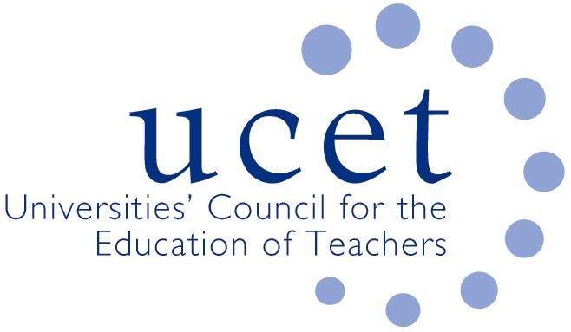
A Registered Charity (No 275082)

9-11 Endsleigh Gardens, London WC1H 0EH

T: 020 7621 6836
info@ucet.ac.uk

Promoting Quality in Teacher Education

Agenda for the UCET Research & International Forum, 1:00 – 3:00 p.m., 21 January 2020, Prince William Suite, Mary Sumner House, 24 Tufton Street, Westminster SW1P 3RB

There will be a morning symposium beginning at 10.15am on ‘The development and sustaining of research cultures through research income pipelines’ led by Mark Boylan (SHU) and others Registration for this symposium can be made via the UCET website or by e-mailing m.fincher@ucet.ac.uk.

- Welcome and Introductions
- Note of the previous meeting and matters arising (enc.)
- General UCET update
- Morning symposia:
  - Feedback from morning symposium
  - Topics for future symposia
- REF issues:
  - Recorded presentation from Tanya Ovenden-Hope (Plymouth Marjon)
  - REF panel membership
  - Other REF issues
- Institutional updates and horizon scanning
- Intellectual basis of teacher education
- UCET strategy
- Building research informed teacher education communities
- BERA blog
- ITE content framework
- UCET NI research into the digital skills of teachers in primary schools
- International issues:
  - Feedback from Forum members on international activities
  - 2020 ICET conference update
  - UCET travel scholarship invitations.
- UCET 2019 Christmas newsletter
- Any other business
- Date of next meeting: 12 May 2020

Background Papers:

- Minutes of the previous meeting
- REF panel membership paper
- ITE content framework
- IBTE paper
- 2019 BER blog digest
- UCET NI Digiskills report
- ICET conference details
- UCET travel scholarship invitation
- 2019 UCET Christmas newsletter

