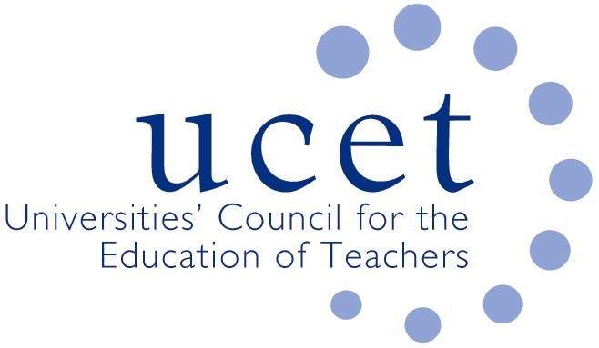
A Registered Charity (No 275082)

Promoting Quality in Teacher Education

Minutes of the meeting of the UCET Northern Ireland Committee held at 10am on Tuesday 1 October 2019 at the Open University, 110 Victoria Street, Belfast BT1 3GN

Attendance

Roisin Mc Philemy (Open University, Chair)
Anne Heaslett (Stranmillis, Vice Chair)
Martin Hagan (St. Mary’s)
Fiona Henry (Open University)
Paul Mc Flynn (Ulster)
James Noble-Rogers (UCET)
Jennifer Roberts (Queen’s)

Apologies

Carl Bagley (Queen’s)
Linda Clarke (Ulster)
Jackie Moses (UCET)

Welcome, introductions and minutes

Colleagues were welcomed to the first meeting of the new academic year, and apologies noted. The minutes of the meeting held on 15 January 2019 were agreed. There were no matters arising that were not covered elsewhere on the agenda.

Institutional updates

These were all covered under other agenda items.

UCET NI research projects

(a): The Teacher Professional Learning Framework (TPLF)

The Learning Leaders Oversight Group, at a meeting on 24th Sept, discussed how the Framework could help to structure and inform the work going forward. A paper based on the framework has been submitted to Teachers and Teacher Education – co-authored by the Research Fellow and the members of the Steering Group. Linda Clarke will be presenting the framework at the SCoTENS Conference in October.

(b): Digiskills

A paper is being drafted and will be circulated to the Steering Group for comments and additions. Funding is being sought from NI Screen and Education Stakeholders for Phase 2 (Post Primary Study). The Phase 1 Executive Summary will be launched soon – in discussion with NI Screen.

ITE allocations

The importance of ITE providers receiving a timely announcement of allocations, as well as allocations covering a two year period to allow for planning, was again stressed by committee members. The apparent mismatch between an alleged over-supply of teachers(as referenced in the recent skills barometer report) in Northern Ireland and the unmet demand for teachers from many schools was also noted. The nature of teacher education being part of an open system in which teachers travel to teach on other parts of the UK and beyond, and teachers from other areas teach in Northern Ireland, was also noted. The value of teacher education programmes in providing the subject knowledge, interpersonal and transferable skills which aspects of the NI economy beyond teaching require was also noted.

UCET NI priorities

It was agreed that, in addition to ongoing business, a priority for UCETNI during the academic year would be to hold an event, building on the success of the May 2019 conference at Stranmillis, in May 2020 (provisionally scheduled for 18 May in the Long Gallery at Stormont) to demonstrate to policy makers, opinion formers and others the broad contribution that teachers education (both ITE and CPD) makes to Northern Ireland. As well as covering issues relating to the recruitment and retention of teachers in Northern Ireland and beyond, the event will cover the role of teacher education programmes in equipping teachers with hard and soft skills such as subject-knowledge resilience, planning, collegiality, communications that are valued in all sectors of the economy, and the reliance of every sector of the economy on the availability of properly trained teachers. The event will also cover the importance of maintaining an infrastructure of teacher education that meets needs in regards the supply of new teachers and the professional development, in the context of Learning Leaders, of existing staff. The event would consist of presentations and the opportunity for individual institutions (through talks and stands) to showcase how what they do contributes to meeting the needs of the economy in Northern Ireland. The voice of employers would also be heard.

Feedback from UCETNI representatives

It was agreed that each UCETNI institution would be invite to share details of which of their staff were represented on each official working group and advisory body, and reminded off the importance of providing regular reports. In respect of the GTCNI, it was agreed that Martin Hagan should be recommended for a second term as the UCETNI representative.

Intellectual base of teacher education group

James Noble-Rogers reported on the development of a set of values and principles that it was felt should underpin teacher education programmes. These would be reflected in the new UCET strategy and act as a reference point for UCET in considering its public policy positions.

Travel scholarship report

Martin Hagan reported on his research funded by the UCET travel scholarship. The next round of scholarship applications would be invited in early 2020.

2019 UCET conference

The draft agenda for the conference was noted. UCETNI colleagues were reminded that they could attend free of charge.

Developments elsewhere in the UK

James Noble-Rogers briefed colleagues on developments including: the review of ITE content in England; a new system for applying for ITE programmes in England; the replacement of pre-entry skills tests; the entitlement for NQTs in England to a structured two-year programme of early professional development; work to ensure consistent assessment against the new teacher standards in Wales; and an event that week on partnership working in Wales.

Items for information

The UCET summer newsletter and the report of the 2019 ICET conference were noted.

Arrangements for the afternoon meeting

These were agreed.

Any other business

None

Date of next meeting

14 January 2020

