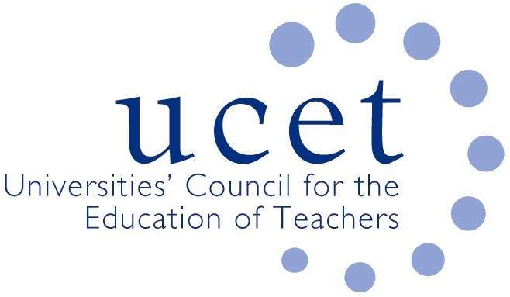

New ITE Content Framework Event

Friday 6th December, 10.00 to 2.30pm
Mary Sumner House, 24 Tufton Street, London SW1P 3RB

Agenda

- Welcome & introductions (10.00-10.05)
- Overview & Development of the New ITE Content Framework: Sam Twiselton (10.05-10.45)
- Reviewing ITE programmes in the context of the ITE content framework: Bea Noble-Rogers and Pat Black (10.45-11.30am)
- Provider level perspectives and plan (11.30am-12.15pm)
  - Emma Turner (Inspiring leaders teacher training)
  - Fiona Leonard (Sheffield Hallam University)
LUNCH: 12.15-1.00pm
- Provider level perspectives, continued (1.00-1.45pm):
  - Leann Lynch (Mount Street Academy)
  - Joanne Clifford Swann (Northumbria University)
- Group discussions and plenary (1.45-2.30pm)
- Close

