The Bristol Handbook for Education Professionals and the Document Summary Service

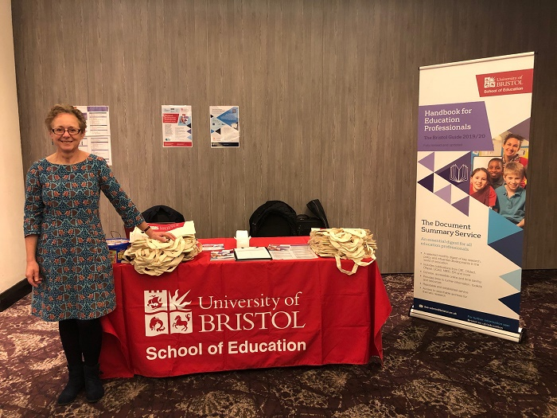

Thank you to everyone who came to visit our stand at the UCET conference. We attended to raise awareness of our two publications for education professions. Both endorsed by UCET.

Bristol Guide
The Bristol Guide is an annually updated handbook for trainee teachers, NQT's and experienced teachers. It offers a compact, comprehensive and credible guide to the English education system. Universities purchase in bulk to give to all their PGCE or Masters students or put it on their recommended reading list. Details can be found here.

https://www.bristol.ac.uk/education/expertiseandresources/bristolguide/

Email us on dss-admin@bristol.ac.uk and quote UCET10 to claim a 10% discount on any order size.

Document Summary Service
The DSS is a selected monthly digest of key research, policy and influential developments in the world of education. Each report is broken down into a two page report and ten of these get sent direct to your inbox monthly to share within the terms of your licence. Included also is an archive system of reports searchable by keywords with over ten years worth of material.

We are running a special discount rate for the conference of 15% discount if you take out an annual subscription. Quote UCET15 at checkout before 15 November 2019. After this time, as a UCET member, you can quote UCET10 for a 10% discount.

https://edn.bris.ac.uk/dss/

If you want any further details, please contact Jacqueline on dss-admin@bristol.ac.uk.

Many thanks

Jacqueline Davies
Commercialisation Officer
School of Education
University of Bristol
Helen Wodehouse Building
35 Berkeley Square
Clifton
Bristol
BS8 1JA

j.davies@bristol.ac.uk

+44 (0) 117 331 4291

Follow @BristolUniDocs on Twitter

A top 10 UK university (QS Rankings 2019)
A top 2 UK university with leading employers (High Fliers 2019)
A top 5 UK university for research (THE analysis of REF 2014)
A top 6 European university for teaching (THE 2018)

