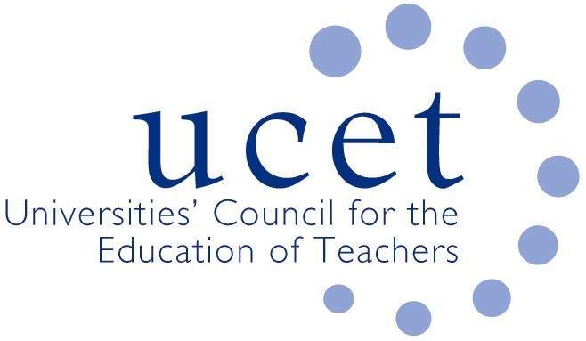
A Registered Charity (No 275082)

Promoting Quality in Teacher Education

Agenda for the meeting of the CPD Forum to be held at 1pm on Tuesday 12 November 2019 at Mary Sumner House, 24 Tufton Street, Westminster SW1P 3RB

There will also be a morning symposium beginning at 10.15.am led by Teaching School Council Chair Richard Gill. If you would like to attend but have not registered please contact Max Fincher at: m.fincher@ucet.ac.uk.

- Welcome and introductions
- Minutes of the previous meeting (enc.)
- Matters arising
- UCET updates
- Morning symposia:
  - Feedback from morning symposium
  - Topics for future symposia
- Context for education departments in broader HEIs, and institutional updates & horizon scanning (enc.)
- Building research informed teacher education communities (enc.)
- Professional learning frameworks: Report from UCET NI commissioned by Department for Education, Northern Ireland (enc.)
- National Professional Qualifications (NPQs)
- Early Career Framework:
  - Results of tendering for pilot phase (enc.)
  - Update on ITE content review
- Legal and ethical responsibility for postgraduate research
- Apprenticeship issues
- Chartered College (enc.)
- Intellectual base of teacher education group (enc.)
- International issues:
  - 2019 ICET conference report (enc.)
  - Feedback on international activities from CPD forum members
- Items for information:
  - Summer 2019 UCET newsletter (enc.)
- Any other business
- Date of next meeting: 11 February 2019

