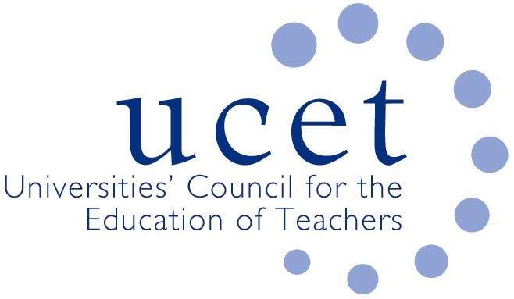
A Registered Charity (No 275082)

Promoting Quality in Teacher Education

Note of the meeting of the UCET CPD forum held at 1pm on Tuesday 3 June 2019 at Mary Sumner House, Tufton Street, Westminster, London SW1P 3RB

Welcome& introductions
Colleagues were welcomed to the final meeting of the CPD forum of 2018/19 and introduced themselves. The note of the previous meeting was agreed. On matters arising, JNR reported that registration for the 5-6 November UCET conference was open at https://www.ucet.ac.uk/conference (with a 10% discount for institutions sending 5 or more delegates, which can include school or college partners), and that points made at the last meeting about the Early Career Framework had been communicated to senior DfE officials.

Discussion

Highlights from the afternoon’s discussions included:

- General updates from UCET covering: Trevor Mutton’s election as UCET Vice Chair; developments in Wales, including the securing of funding for HEIs to support partnership working following a meeting between USCET and the Welsh government; a UCET NI conference showcasing the contribution that HEIs make to teacher education and teacher supply in Northern Ireland; the new UCET lifetime achievement award; and the development of the new OfSTED ITE inspection framework.
- Feedback from the morning symposium/Teach Meet which had been led by: Rachel Lofthouse; Rania Hafez; Jenny Carpenter; Lizana Oberholzer; and (by video) Richard Holme. Key points had included: the quality assurance of M Level credits awarded by other institutions; the delivery of programmes with no academic credit, and the scope to use them to then recruit to M Level; the popularity amongst teachers of receiving certificates and other formal recognition for programmes undertaken; the need to tailor programmes to the needs, size and shape of particular teachers and schools; the importance of CPD offers being flexible to teacher needs; and the sometimes limited capacity of staff to engage with teacher education partnerships. Suggestions for future symposia included: the implications of teaching school changes and opportunities for collaborative working; values and principals underpinning CPD programmes; and a round-table on international activities.
- Institutional level reports and questions, covering: the identification of capacity to deliver non-accredited CPD; the realignment of CPD offers; the taking account of values issues when considering whether to accredit CPD delivered by other organisations; ethical considerations and constraints in regards practitioner enquiry; the level at which master’s programmes become financially unviable; and opportunities and threats posed by alternative models of delivery such as on-line.
- The work of the UCET Intellectual Base of Teacher Education Group.
- The Early Career Framework, for which tenders to develop curriculum materials and deliver programmes in the pilot areas were expected to be invited soon, with an emphasis on partnership delivery. Concern was expressed about the possibility that mandatory curriculum materials would undermine the scope to tailor programmes to individual needs, although public investment in CPD and the opportunity to refine the ECF over time were welcomed.
- The establishment of a group to review ITE content in the light of the ECF, where UCET would use its inclusion to protect and promote: flexibility, the academic underpinnings of ITE programmes and the importance of teachers being equipped to interpret, contextualize and carry out their own research.
- International activities, including the forthcoming ICET and ATEE conferences, the accreditation of overseas CPD programmes; the sustainable development project; and Gordon Kirk Travel Scholarship winners.
Date of next meeting

12 November 2019.

