**International Council on Education for Teaching (ICET): Report of Annual World Assembly, Glenburn Lodge, Johannesburg, 8-11 July 2019**

Introduction

The sixty-third annual World Assembly of ICET (and the 13th with a formal UCET representation) took place at the picturesque Glenburn Lodge and Spa, a short distance from Johannesburg, on the 8-11 July, with the annual meeting of the ICET Board (of which JNR, Linda la Velle from Bath Spa and Ivan Reid from York St. John are members) at the neighbouring Kloofzicht Lodge on 7 July. The settings are based in South Africa’s ‘Cradle of Humanity’, the location of the first recorded human beings. Although there are no wild game in terms of the ‘big five’ roaming free, there was nonetheless abundant wildlife walking around in the form of various species of antelope, wild boar and monkeys. A great setting for what tuned out to be an excellent conference.

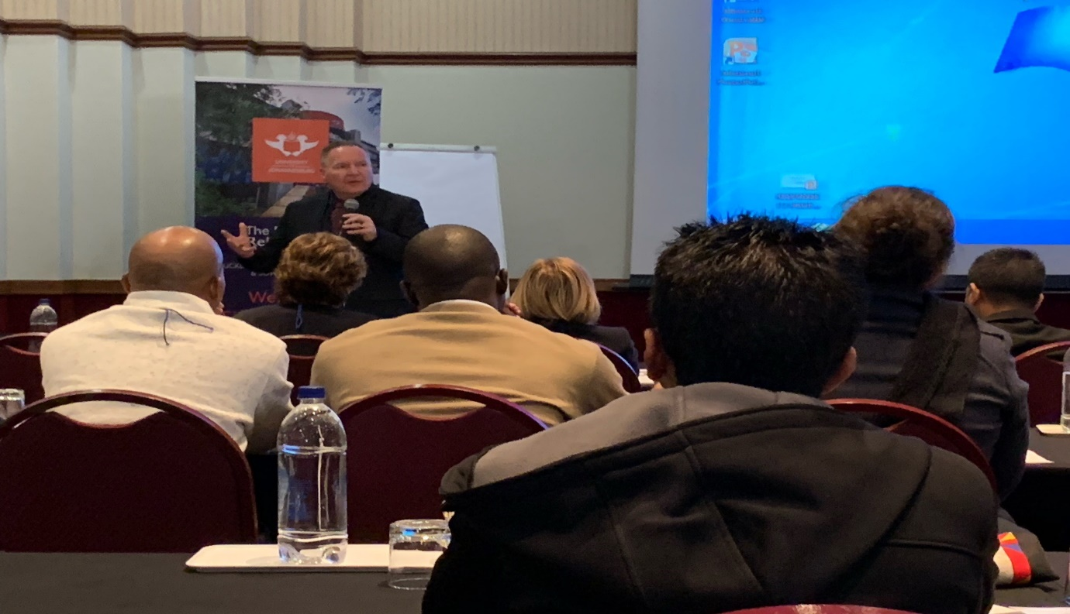

*ICET president James O’Meara opening the proceedings*

Keynotes

The theme of this year’s World Assembly was the implications for education of the fourth industrial revolution (referred to throughout as ‘4IR’). The opening keynote was delivered by *Wesley Doorsamy*, although he was delivering it on behalf of the original speaker *Professor Tshilidzi* from the University of Johannesburg. The 4IR was said to follow on from the previous three industrial revolutions which had been characterised by the use of steam; the use of assembly lines; and computing & the use of nuclear energy. 4IR is typified by the use and manipulation of vast amounts of digital data, which is forecast to increase from the current 40 zettabytes to some 163 by 2025. Data is the new gold, which is being increasingly mined through social media, interactive TV, internet usage etc., and is linked to developments in Machine Learning and Artificial Intelligence, areas within which increasing numbers of jobs can be expected to develop. Unlike previous industrial revolutions, the 4IR is not going to be constrained by limitations on the availability of physical and human resources. Existing jobs that are dull, repetitive and dangerous and will be replaced by new opportunities (it was unfortunate that a wide range of jobs, many of which were highly ethical and demanding, were rather patronisingly lumped together in one ‘redundant’ category). Just as jobs requiring more cognitive skills developed during earlier periods of mechanisation, new jobs will emerge as those cognitive jobs themselves are taken over by Artificial Intelligence and Machine Learning. He then went onto argue that higher education (generally, not teacher education, which was not specifically addressed) continued to be geared to meeting what are increasingly outdated paradigms, something which will make it more difficult for HE in South Africa and beyond to respond to the world’s changing needs. The HE sector should, instead, aim to become the driver of the 4IR, although budgetary constraints (especially in South Arica) could make this difficult. The HE sector needs to move towards more lifelong learning, towards mass education and away from catering to elites and to make the most of new technology and to take the lead in adapting that technology to meet different needs. In the regional context, this would be facilitated by increasing pan-Africanisation, particularly given the fact that by 2025 Africa will contain some 40% of the world’s working age population (assuming of course, the definition of ‘working age’ does not keep expanding). In conclusion, it was argued that HE should: adapt fast and quickly; encourage broader thinking in terms of the curriculum; help adaptive behaviour and lifelong leaning become the norm; create critical thinkers with practical skills; and develop inter-disciplinary curricula that are adaptable to local contexts. The talk was interesting, if not sufficiently education focussed. It did (like several other of the keynotes) assume a mind-set of brave new world inevitability. This was challenged by the respondent of Professor *Nazzim Carrim* from the University of Witwatersrand who entertainingly and convincingly challenged the prevailing narrative that the new technology will lead to sunlit uplands, pointing out that it was equally likely to result in greater polarisation (between individuals and different parts of the world) and the accumulation of wealth in ever-fewer hands. It is also, he said, wrong to assume that we can simply adapt 3IR technology to meet the demands of 4IR, especially given that we have as yet no understanding of what cyber-physical systems might look like. It is also a mistake to prioritise STEM at the expense of the liberal arts and the wholesale acceptance of a positivist paradigm. An instrumentalist approach to knowledge based entirely on economic needs should be avoided. Robots cannot operate in the same cognitive ways as humans. Who, he asked, will 4IR benefit and who is it intended to benefit? Blithely telling people that they need to adapt to meet the inevitable is neither helpful nor productive.

The second keynote, preceded by the presentation of lifetime achievement and research awards to ICET Board members Shirley Van Newman and Maria Flores, was titled ‘*Technology flight in the 4IR humbles teaching again’* and was delivered by *Professor Winston J Akala* from the University of Nairobi. Teaching is, he argued, one of the last professions to embrace new technology, despite the fact that technology is often targeted towards the improvement of teaching. And while learning institutions do use technology (albeit often out of date) they rarely drive it. Teaching is, as a result, humbled. Teaching should not attempt to resist technology; it should use it, embrace it, contextualise it and help to develop it. Fears about the loss of jobs, including teaching jobs, because of technology are misplaced and ignore the fact that the new technologies did not develop out of a vacuum. Teachers should work with technology, including robot technology, rather than resist it. He went onto give the example of countries in Africa, where from a review of institutional websites it appeared that only eight of the 164 African universities surveyed included strong technological themes within their teacher education programmes. This suggests that the academy will struggle to meet the technological challenges of the 21st century and schools will, because their teachers are not trained, fail to make the most of the new technologies and will be increasingly left behind. The keynote was again buying into the positive mindset relating to new technologies. It also appeared not to take proper account of the African context. Is technology a priority for teacher education when most schools do not have the infrastructure to even attempt to access the new technology? This point was not however taken up by the respondent, *Professor Freddie Msiska* from Malawi, who agreed that the education sector should embrace and not resist technological change.

The final keynote of the World Assembly was from *Professor Sarah Gravett* from the University of Johannesburg on *‘Education & Teacher Education for a rapidly changing world and uncertain future’*. New technology will, she said, result in a volatile, uncertain and ambiguous future, and education must do what it can to provide people with the skills and competencies they will need to adjust. The question for teacher education however, is: should it prepare people to work in schools as they are now, or as they will be in the future? Does ITE need reimagining and, if so, how? Reference was made to a range of competency frameworks from UNESCO, OECD and others, and Andreas Schleicher’s views about the importance of not only what people know, but also how they behave and how they adapt. In the light of this, what do teachers need to know and how should that be reflected in ITE? She referred to often repeated claims about teacher education being too theoretical, with a disconnect between what happens in ITE and what takes place in school. The best ITE programmes should integrate theory and practice. Subject knowledge she said could be assumed to be a continuing feature of good teacher education programmes. Other aspects, however valued and assumed to be ubiquitous and have intrinsic value, might need to be abandoned. People only remember what they use. Including things in ITE that teachers will not use is pointless and will take up time that could be better spent (this would however seem to imply that teachers will soon forget any aspects of their ITE relating to new technology if that technology is not available in schools). Teacher education should, in David Perkin’s terms, be ‘future-wise’. ICT is not sufficiently embedded in ITE, with just 40% of teachers according to TALLIS reporting that ITE made them feel competent in its use (although this could reflect the ‘being told enough to understand what they don’t know’ issue). ITE also needs to keep up-to-date with new developments in neuroscience. Teachers need to have access to new knowledge and be able to contextualise, critique and apply that knowledge. Life-worthy knowledge will make life-ready teachers. Life-ready knowledge will help to bridge the theory-practice divide. In conclusion, ITE programmes should be carefully assessed using life-worthiness for the future lives of teachers as a yardstick. This requires conversion to life-ready knowledge that fosters within ITE deeper learning. This is time-consuming and will therefore require changes to be made to the ITE curriculum, including the abandonment of some long-standing and previously treasured components. The respondent was *Maureen Robinson* from Stellenbosch University who agreed that while some aspects of ITE were enduring and there was much to hold onto, teacher educators should not be defensive or keep hold of trusted favourites just for the sake of it. The education sector should be involved in the debate about the development of new technology, and to help that more senior positions in HEIs should be held by professional educators. ITE must cover new ideas relating to, for example, coding and robotics. New jobs will require new skills. She also pointed out that new technology could not be forced into schools that are not ready, that we should be wary of quick-fix technological solutions offered by the private sector, and that schools in Africa had other priorities (e.g. sanitation). ITE needs to retain its own space, and approach the 4IR from a perspective of redistribution, recognition of school contexts and representation in terms of all parts of the world and all parts of the community.

That concluded the keynotes and responses. Although interesting, the main keynotes did all sing to a similar tune: they implied a deficit model of ITE and predicted a rosy future, with no recognition that futures very rarely turn out as predicted and that the 4IR could make things worse rather than better. There was also only limited reference to the African context. The only real challenge came from the first respondent, and to an extent the third. The new system of having respondents did however work well.

Parallel sessions

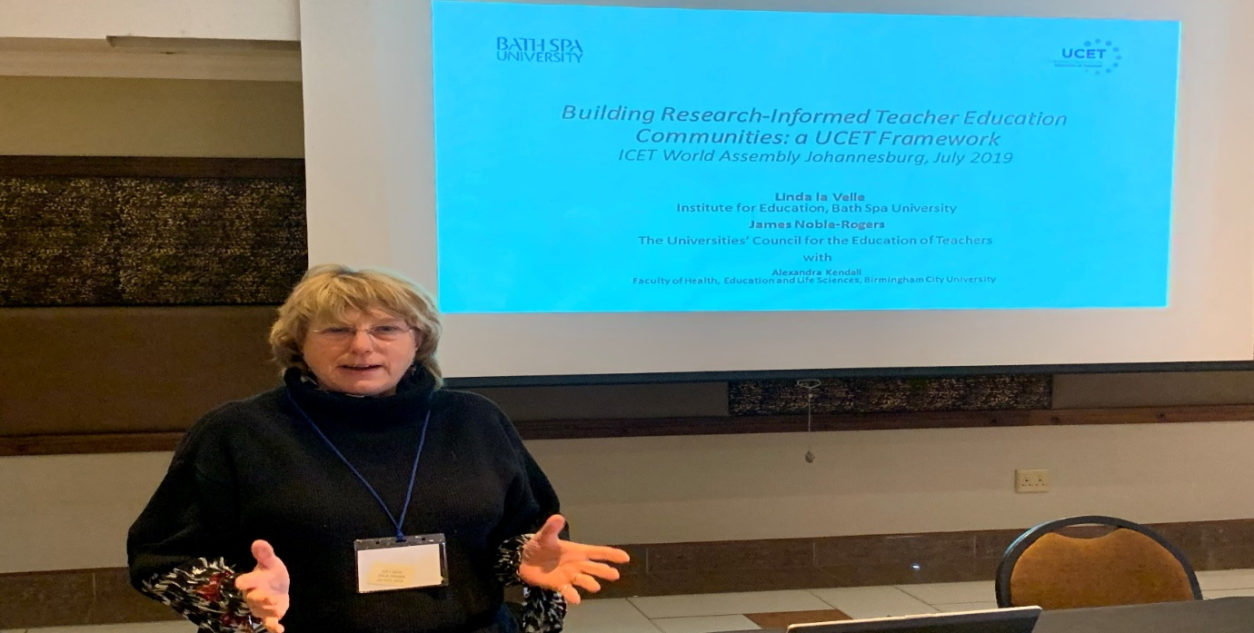

*Linda la Velle o the UCET ‘Building Research Informed Teacher Education Communities’ paper*

Much of the meat of the World Assembly came from the one hundred or so parallel sessions, the brief for which extended beyond the 4IR theme that dominated the keynotes. The sessions were led by people from around the world, albeit with a high representation from South African colleagues. Those with a UK input included*: James Noble-Rogers and Jackie Moses* from UCET speaking about teacher recruitment and retention in England; *Linda la Velle* from Bath Spa and *James Noble-Rogers* on the recent UCET paper ‘Building research informed teacher education communities’; *Sarah Younie* from De Montfort on the MESH guides*; Bea Noble-Rogers, Akwasi Addae-Boahene and Eric Ananga* with a number of sessions on aspects of on teacher education reform in Ghana; and *Linda la Velle* on how to get research published.

Cultural activities

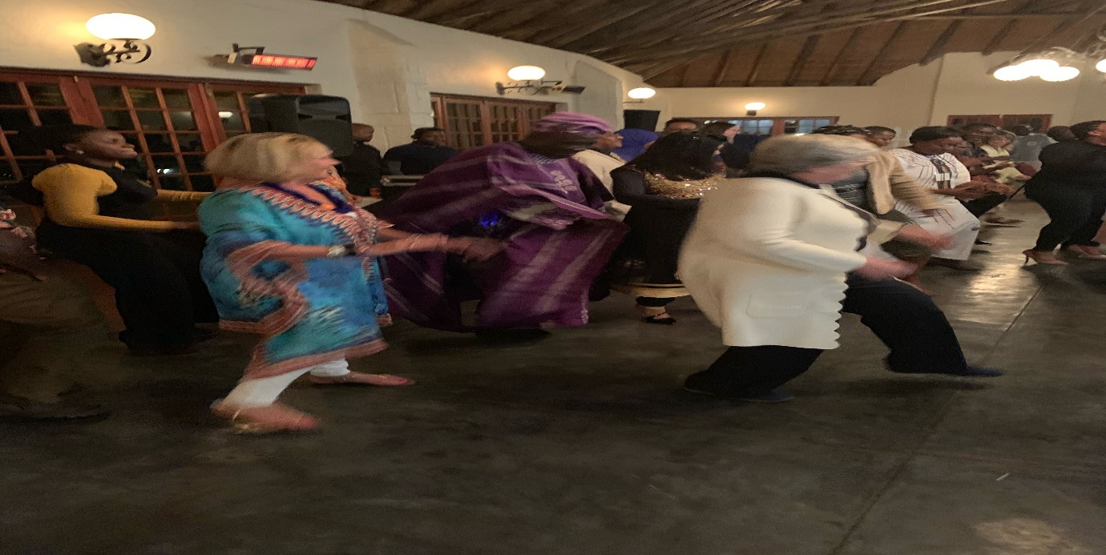

*Dancing at the Gala Dinner*

This year’s cultural activities included a welcome reception hosted by dignitaries from Johannesburg City Council, which went well other than for the fact that what should have been a 30 minute drive took one-and-a-half hours because the coach driver got lost (something we realised as buildings we past began to appear very familiar). We discovered later that the driver’s Satnav was upside down and he was for a while turning right instead of left. He eventually dropped us close to the City Hall, from where we took a short walk at night through what is reportedly one of the most dangerous cities in the world. The gala dinner two nights later was a greater success (although for three of us the transport was a police car, which we had mistakenly flagged down thinking it was the official minibus), with excellent music, involving what for us were novel instruments (e.g. drums in a water bowl) from university students, who we had assumed from the quality of their performance were professional musicians. This was accompanied by much dancing and merriment.

Annual General Meeting

The World Assembly closed with the Annual General Meeting, the highlight of which was the announcement that the 2020 World Assembly will be held at Bath Spa University in the UK. UCET will circulate details in due course, and will of course be represented.

Following the conference, the Noble-Rogers went on a short safari, during which several gruesome ‘red in tooth a claw’ events were witnessed, and the end of the Cricket World Cup was missed because we had to divert our truck for fear of being attacked by a very angry looking bull-elephant. We expect different adventures in Bath next year!

JNR

August 2019