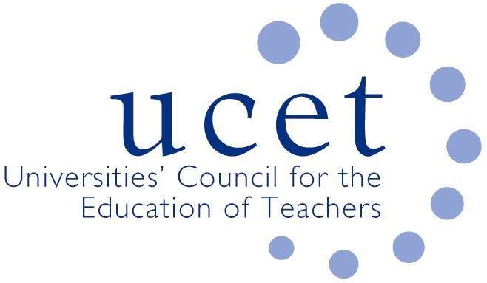
A Registered Charity (No 275082)

Promoting Quality in Teacher Education

Note of the meeting of the Post 16 forum held at 1pm on Friday 24 May 2019 at Mary Sumner House, Tufton Street, Westminster, London SW1P 3RB

Welcome, introduction & notes
Colleagues were welcomed to the final meeting of the Post 16 forum meeting of 2018/19. The note of the previous meeting was agreed. On matters arising, JNR reported that a number of meetings had taken place with regard to mental health & well-being, including one with the Duchess of Cambridge.

Discussion

Highlights from the afternoon’s discussions included:

- General updates from UCET covering: developments in Wales, including the securing of funding for HEIs to support partnership working following a meeting between USCET and the Welsh government; a UCET NI conference earlier that week showcasing the contribution that HEIs make to teacher education and teacher supply in Northern Ireland; the early career framework for school-teachers in England and the establishment of a government advisory group (with UCET representation) to review ITE content in the light of the ECF; the work of the UCET intellectual base of teacher education group; and developments relating to the REF.
- FE teaching apprenticeships, including feedback from the morning symposium which had been led by Mary Osmaston, Noell Graal and Victoria Wright. Key points included: the potential for providers to be moved from the list of apprenticeship delivers if inactive for a period of time; the burdensome nature (over and above DET requirements) of the EPA; the need for training for those carrying out End Point Assessments; the inflexibility of IFA and EFSA rules; and the delivery by HEIs of Academic Professional Apprenticeships (not always by education departments). Suggestions for future symposia included a presentation from the Association of Colleges, T Levels and the carrying out of End-Point-Assessments.
- Recruitment to PCET programmes, where there was a mixed picture, with pre-service programmes generally doing better than in-service, although the late withdrawal of bursary funding had had a negative impact. On student support, it was confirmed that in order to access loan support DET students should be on 120 credit programmes delivered at level 5 or above.
- DfE colleagues reported on: measures to encourage recruitment that would be announced in the light of the spending review; FE representation on the Mental Health & Well Being expert group; and the taking account of the FE sector in digital teacher supply developments.
- The inclusion by a number of the institutions represented if FE components of education studies degrees (although most had, a primary or early years focus).
Coverage to an extent was felt to depend on the background of those delivering the programmes
- Updates from the Education & Training Foundation, including: modest revisions expected to be made to DET programmes for 2020; professional development packages for teachers relating to the introduction of T levels; the incorporation of T levels into ITE; the Talent to Teach (formerly ‘pathways programme’) which has placed 360 final year undergraduates on 40-hour teaching placements in FE colleges; on-line training for teacher educators; and SEND training programmes for generalist teachers.
- The development of the new OfSTED ITE inspection framework, and the recent OfSTED questionnaire on ITE content.
Date of next meeting

18 October 2019.

