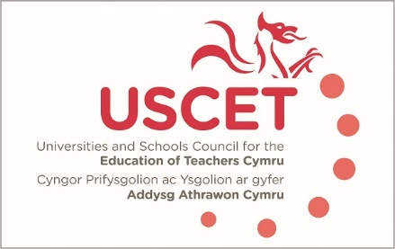

Agenda for the meeting of the University and Schools Council for the Education of Teachers (USCET) to be held at 10am on Thursday 17 October 2019 at the Media Resource Centre, Oxford Rd, Llandrindod Wells LD1 6AH

10.00am-11.15 am:
- Welcome & introduction
- Minutes & matters arising
- Vice Chair of USCET
- Feedback from USCET partnership event, inc. USCET Terms of Reference and coverage and membership of sub-groups
- Updates from regional consortia and accredited providers
- Literacy and numeracy tests
- Entry requirements for ITE
- ITE developments in other parts of the UK
- UCET Summer 2019 newsletter
- UCET 5-6 November conference programme
11.15am-12.30pm:
Welsh Government, EWC, Qualification Wales and Estyn colleagues to join meeting
- Updates from:
  - Welsh Government
  - Estyn
  - Education Workforce Council
  - Qualifications Wales
- Consistent assessment of student teachers against the new teaching standards
- Accreditation of programmes and the allocation of ITE places
- Equivalency tests
- Professional Learning Passport
12.30-1.00pm: Lunch

