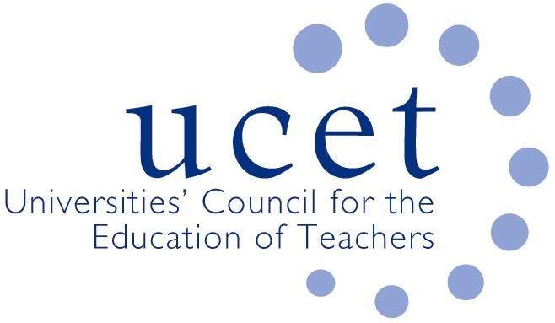
A Registered Charity (No 275082)

9-11 Endsleigh Gardens, London WC1H 0EH

T: 020 7621 6836
info@ucet.ac.uk

Promoting Quality in Teacher Education

Note of the meeting of the UCET Research & International Forum held at 1pm on Tuesday 14 May 2019 at Mary Sumner House, Westminster, London SW1P 3RB

Welcome, introductions and note of the previous meeting

Forum colleagues were welcomed to the meeting, with those attending for the first time given a particular introduction. The note of the meeting held on 22 January 2019 was (subject to the correction of typographical errors) approved.

Discussions:

Forum members discussed a range of issues linked to the meeting agenda, including:

- Updates from UCET on non-R&I issues, including: the Early Career Framework and forthcoming invitation to tender; inspection issues, including controversies surrounding a recent OfSTED questionnaire on ITE content; the formation of a working group to consider ITE content in the context of the ECF; mental health in teacher education developments; the following week’s meeting in Northern Ireland about the HE contribution to teacher education; and recent developments in Wales.
- Feedback from the morning symposium on REF 20121 which had been led by Education Sub Panel Chair David James. Key points included: the transparent nature of the REF process; the scope sub-panels have to take their own decisions; the importance of only education related outputs being submitted under the education UoA; the panel being ‘of the field, and for the field’; advice that institutions should avoid ‘game-playing’; and the scope to recommend new panel and sub-panel members. Some concern was expressed that new requirements relating to the publication of institutional policies on which staff to submit would indirectly benefit certain types of institution that may have made changes to staff contracts prior to the new REF round, although some felt that there might be scope to address this in environment statements. Recent announcements about REF procedures and institution-level environment statements were noted. It was agreed that forum members would be invited to submit questions about the REF for UCET to raise on their behalf, and that volunteers should be invited to lead discussions at the next morning symposium on the drafting of environment statements. It was also agreed that, after June 7, forum members would be invited to share thoughts on the definition of ‘significant contribution to research’.
- An update was given on the work of the UCET Intellectual Base of Teacher Education group, which was in the process of developing values and principles that should underpin effective teacher education and inform UCET policy positions in the context of its new strategy for 2020 inwards. It was suggestion that the range of ITE and CPD initiatives being developed by emerging providers might be examined in the context of the values and principles.
- The proposed research strand at the 5-6 November UCET conference, contributors to which were invited.
- Reports from institutions, including: the implications of differing institutional systems, structures and procedures; research into various ‘neuro-myths’ that seem to be having an impact despite possibly be based on research from age cohorts other than learners in schools; and differences on research arrangements and cultures in different parts of the UK.
- International issues, including: recipients of the 2019 Gordon Kirk travel scholarship; the recent OECD report on global trends in education; the forthcoming ICET conference in South Africa; and reports on international activities from forum members.

Date of next meeting

8 October 2019

