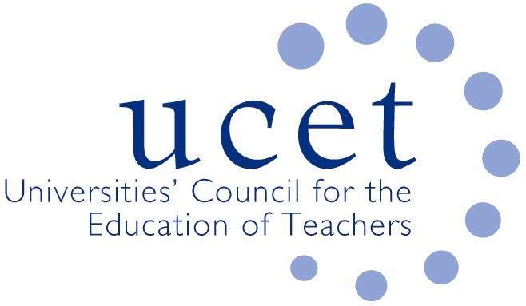
A Registered Charity (No 275082)

9-11 Endsleigh Gardens, London WC1H 0EH

T: 020 7621 6836
info@ucet.ac.uk

Promoting Quality in Teacher Education

Agenda for the UCET Research & International Forum, 1:00 – 3:00 p.m., 8 October 2019, Princess William Suite, Mary Sumner House, 24 Tufton Street, Westminster SW1P 3RB

There will be a morning symposium beginning at 10.15am on ‘the drafting of environment statements’. Registration for this symposium can be made via the UCET website or by e-mailing m.fincher@ucet.ac.uk.

- Welcome and Introductions
- Note of the previous meeting and matters arising (enc.)
- General UCET update
- REF:
  - Feedback from morning symposium
  - REF questions and answers (enc.)
  - Other REF issues (see website links)
- Future symposia
- Institutional updates and horizon scanning
- 2019 UCET conference:
  - Draft conference programme (enc.)
  - Research strand at conference
- Intellectual basis of teacher education: values & principles statement (enc.)
- Building research informed teacher education communities (enc.)
- UCET NI research into professional leaning frameworks (enc.)
- International issues:
  - Commonwealth Education Trust presentation
  - Feedback from Forum members on international activities
  - 2019 ICET conference report (enc.)
  - 2020 Bath Spa ICET conference announcement
- Items for information:
  - UCET 2019 Summer
- Any other business
- Date of next meeting: 21 January 2020

Background Papers:

- Minutes of the previous meeting
- Building Research Informed Teacher Education Communities paper
- REF questions & answers
- IBTE vales & principles statement
- NI professional learning frameworks research report
- 2019 ICET conference report
- 2019 UCET summer newsletter

