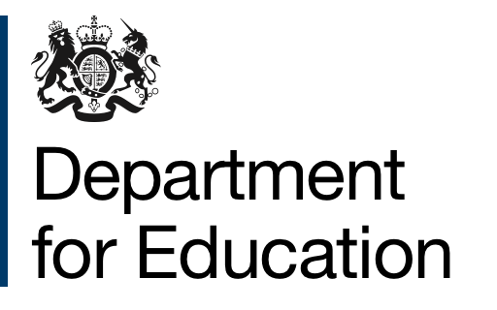

DfE is building a new digital application service for prospective trainee teachers

Apply for postgraduate teacher training (‘DfE Apply’, for short) will be DfE-owned and run. Over time it will replace the UCAS Teacher Training (UTT) application service.
Like its sister service DfE Find, DfE Apply will be an important part of delivering the Teacher recruitment and retention strategy, encouraging candidates from a wider and more diverse pool of talent.

Benefits for providers  A smooth application journey, giving you the information you need to make accurate and efficient decisions  A streamlined and user-friendly provider interface so you can manage applications, interviews and conditions.  For providers using student record systems, integration with your existing software. | What do providers need to do?  At the moment, you don’t need to do anything. DfE will update you regularly as we build and roll-out the service.  If you have any questions, or would like to arrange a meeting with the team to talk about the new service in more detail, please contact sarah2.fisher@education.gov.uk

Timeline
Ongoing Test and build | DfE is running a ‘concierged’ end-to-end test of the service with the help of real candidates and providers.  The test will use manual and low-fi tools to take candidates from submission to enrolment. In this way, we’ll learn about provider processes and needs.  Concurrently, DfE is building a digital service which we’ll continue to test with providers and candidates, building their feedback into our designs.
From November 2019  Pilot | DfE will pilot its live digital service with a small number of providers who have opted in.  This live service will take real candidates through the application process, enrolling them on to courses run by our opted-in providers.  We’ll continue to seek your feedback throughout our pilot, to ensure we address any concerns.
2020  Rollout | The DfE Apply service will start to rollout across the provider market. This rollout will be designed to minimise provider and candidate inconvenience.  Segmenting this rollout by location, subject, route and year of entry are under consideration – we’ll consult with you and share our plans as they develop.
2020/2021 and beyond | Ongoing research, design iteration and gradual rollout to avoid the risks of a single, very large product release.  Ever increasing numbers of providers are brought into the service, with a view at the appropriate time for DfE Apply to cover the entire provider market.

For the next few cycles, DfE Apply and UTT will run in parallel. Our plans for roll-out will aim to minimise the number of candidates having to use both services. We will gradually increase the numbers of courses available through DfE Apply as the transition progresses, until eventually all providers have been onboarded.

DfE will work with UCAS to provide clear guidance and support for both candidates and providers to ensure the transition runs smoothly. We will work with you to get your feedback on our proposed changes and the timeframes for implementing them.

Thank you for your ongoing cooperation and support!

The DfE Apply team

