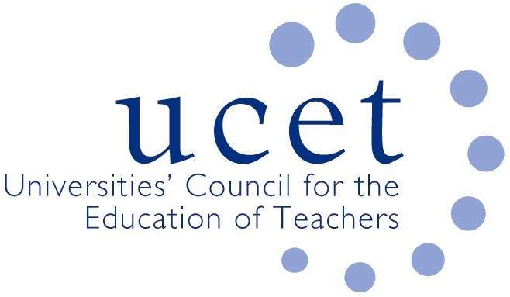
A Registered Charity (No 275082)

Promoting Quality in Teacher Education

Minutes of the meeting of the UCET Northern Ireland Higher Education Liaison Group held at 12noon on Tuesday 15 January 2019 at Ulster University (City Campus), York Street, Belfast BT15 1ED – Boardroom (BA-03-019)

Attendance:

John Anderson (ETI); Paul Brown (DE); Linda Clarke (Ulster, Chair); Pamela Cowan (Queen’s); Kyle Chrutchley (DE); Gerry Devlin (GTCNI); Sam Gallaher (GTCNI); Anne Heaslett (Stranmillis); Julie Humphries (DE); James Noble-Rogers (UCET); Peter Finn (St. Mary’s); Martin Hagan (St. Mary’s); Roisin R.McPhilemy (OU); Paul McQueen (Ulster); John Unsworth (EA).

Apologies:

Carl Bagley (Queen’s); Gavin Campbell (DFE); Jackie Moses (UCET).

Welcome & introductions

All were welcomed and apologies noted.

Minutes of the previous meeting & Matter Arising

The minutes of the meeting held on 2 October 2018 were (subject to typos) agreed. On matters arising it was agreed to circulate the slides used as part of the research presentations.

Business from Chair

The Chair reported that UCET NI would be holding a high profile event on teacher education and the higher education sector on the morning and early afternoon of 21 May 2019 at Stranmillis University College. The event would include a range of plenary presentations on the historical cornet of teacher education in Northern Ireland, the diverse and yet cohesive contribution made by the HE sector and prospects for future developments. Presentations would also be made by each of the five higher education institutions. Colleagues from government departments, the media, the inspectorate, the professional associations and representative bodies would all be invited. NIHEG members welcomed the plans and agreed to contribute and encourage attendance.

The Chair also reported that the 7 May meeting of NIHELG would not take place, given that NIHELG colleagues would be at the 21 May event.

ITE allocations

The request from UCET NI for early notification of ITE allocations, and the reinstatement of two year allocations, had been passed to the Permanent Secretary and was being considered, with legal advice also requested on the scope for the Permanent Secretary to make decisions in the absence of ministers. The introduction of open recruitment (with no adverse consequences) in England was noted. The possibility of a UCET NI research project into teacher supply was also referred to.

Research projects

Updates on the professional learning framework and Digi-skills projects were provided.

WISE

Concern was expressed by UCET NI members about the lack of funding to support Shared Education initiatives in the teacher education sector, despite the fact that ETI had expectations of HEIs in this regard. DE and EA officials indicated that they were disappointed that IFA had refused funding. Reference was made to EU Peace Plus funding and any scope to mainstream SE funds. It was suggested that UCETNI would be invited to a meeting between DE and the funders to discuss the issue further and this suggestion was welcomed by the Chair.

SCoTENs

Department for Education colleagues said that they had not received any representations from the Taoiseach’s office about SCoTENs funding. Further discussions on the issue might prove helpful. JNR to contact Taoiseach’s office. SCoTENs chairs to be encouraged to make representations on the issue.

Recognition for schools engaged in teacher education partnerships

It was suggested that ETI should recognise in its inspection reports the participation by schools in teacher education partnerships with HEIs, and regret was expressed that some schools that had refused to engage with teacher education had received outstanding grades. This need not, it was pointed out, entail an inspection of teacher education partnerships but merely a recognition of involvement. The importance of schools and teachers engaging with the education and development of new teachers was broadly recognised and it was agreed that the issue should be considered further.

Registration fees

Arrangements for recognising the qualifications across the North-South border were regularly discussed at meetings between the respective teaching councils, and fees were charged in both directions. Consideration might be given to streamlining the process. Sam Gallaher agreed to raise the matter further.

Updates from partner organisations

The following updates were received:

- EFA: Gavin Boyd would soon be retiring as interim CEO and would be replaced by a by Sarah Long as permanent CEO. John Collins was about to retire and would be replaced by Kim Scott as Acting Director of Education. Recruitment was also taking place in the Professional Learning Team as part of a restructuring. A range of Teacher Professional Learning Seminars for schools would be taking place under the Learning Leaders Strategy.
- DE: The Learning Leaders strategy continued to be implemented, and the working group on the development of professional standards had been established, with Audrey Curry from Stranmillis representing UCETNI.
- ETI: Visits to student teachers on school experience would be completed by 24 January. The dates of ETI inspection visits to ITE providers had been agreed. ITE inspection reports might again include descriptions of innovative and exemplary practice. Self-evaluation resources on teacher professional learning had been produced for DE colleagues. The Chief Inspector’s annual report had been published in November. Dissemination events, supported by video resources, would take place in March.
- GTCNI: Work was continuing in regards leadership competencies. The process for accrediting ITE programmes was progressing. A new GTCNI council would be elected in due course. A new website and registration system were in development.

Any other business

None.

Date of next meeting

To be confirmed.

