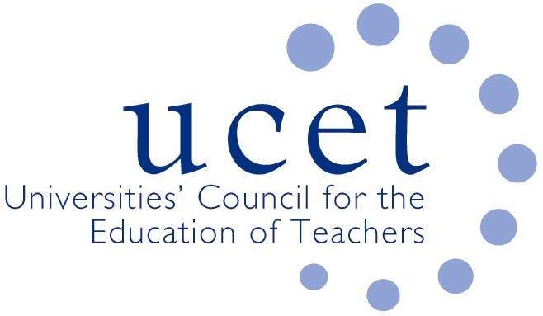
A Registered Charity (No 275082)

Promoting Quality in Teacher Education

Agenda for the meeting of the NIHELG to be held at 12noon on Tuesday 1 October 2019 at the Open University, 110 Victoria Street , Belfast BT1 3GN

- Welcome and introductions
- Minutes of the previous meeting (enc.)
- Matters arising:
  - Recognition for schools involved in teacher education
  - UCET NI showcasing event
  - ITE allocations
- UCET NI research projects:
  - Research into professional learning frameworks (enc.)
  - DigiSkills
- Teaching post applicants
- Updates from:
  - Government departments
  - Education & Training Inspectorate
  - Education Authority
  - GTCNI
- Other matters raised during morning UCET NI meeting
- Any other business
- Date of next meeting: Tuesday 14 January 2020

