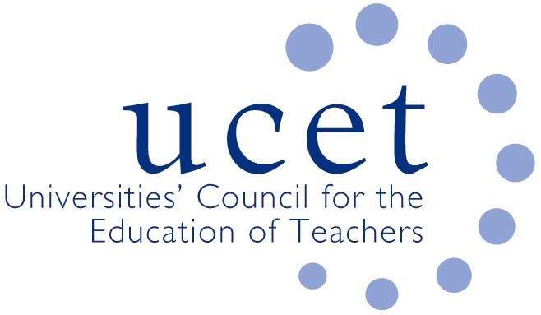
A Registered Charity (No 275082)

Promoting Quality in Teacher Education

Agenda for the meeting of the UCET Northern Ireland Committee to be held at 10am on Tuesday 1 October 2019 at the Open University, 110 Victoria Street , Belfast BT1 3GN

- Welcome and introductions
- Minutes of the previous meeting (enc.)
- Matters arising
- Updates from member institutions
- UCET NI research projects:
  - Research into professional learning frameworks (enc.)
  - Research into digital education in primary schools (enc.)
- ITE allocations
- UCET NI priorities for the year ahead
- Intellectual base of teacher education: vales & principles (enc.)
- Feedback from UCET NI representatives on committees & working groups
- Travel scholarship report
- 2019 UCET conference programme (enc.)
- Oral report on developments elsewhere in the UK
- Information items:
  - UCET summer 2019 newsletter (enc.)
  - 2019 ICET conference report (enc.)
- Arrangements for NIHELG meeting
- Any other business
- Date of next meeting: Tuesday 14 January 2020

Please note: The meeting will be followed at 12 noon by the Northern Ireland Higher Education Liaison Group.

