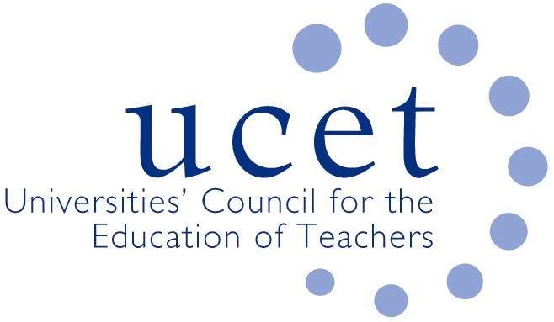
A Registered Charity (No 275082)

9-11 Endsleigh Gardens, London WC1H 0EH

T: 020 7621 6836
info@ucet.ac.uk

Promoting Quality in Teacher Education

Note of the meeting of the UCET Post 16 Forum held at 1pm on Friday 8 February 2019 at Mary Sumner House, Westminster, London SW1P 3RB

Welcome, introductions and note of the previous meeting

Forum colleagues were welcomed to the meeting, with those attending for the first time given a particular introduction. The note of the meeting held on 19 October 2018 was approved. On matters arising, significant disappointment was expressed about the previous day’s announcement that bursary funding for pre-service maths and English trainees and SKE was being withdrawn. UCET had issued a robust statement that had been reported in the press, and would raise the matter at the following week’s meeting with Minister of State Ann Milton.

Discussions:

Forum members discussed a range of issues linked to the meeting agenda, including:

- Updates from UCET on non-Post 16 forum issues, including: the new DFE teacher recruitment & retention strategy, the Early Career Framework, the first meeting of the UCET group looking into the intellectual basis of teacher education and a planned UCET NI event in Belfast.
- Feedback from the morning symposium which included sessions on: ‘Resilience, mindfulness & well-being’ from Ellen Butler & Dean Howes, Alison Hramiak, Karen Duffy & Russell Shobrook and ‘Teaching resources for subject specific pedagogy’ led by Kevin Orr. It was agreed that the topic for the next symposium would be on FE teaching apprenticeships, with a possible subject for a subsequent event being a professional framework for digital teaching.
- Recruitment to PCET teacher education programmes, where it was reported that: (i) higher recruitment than in 2018, possibly because of a new location; (ii) relatively low number of recruits, albeit higher than two years previously; (iii) success in terms of targeting third year undergraduates for recruitment; (iv) numbers comparable to last year, although the withdrawal of bursaries will have a negative impact; (v) in-service finding it difficult to recruit. The general feeling was that the fall in recruitment had steadied, although the impact of bursary changes had yet to impact.
- An update from the Education & Training Foundation covering: the process for reviewing the DET in the light of the English & maths agenda, T Levels, SEND issues and apprenticeships, where the consensus of the group was that ETF should make only minor adjustments pending a more comprehensive review for 2022 in the context of the planned level 4/5 review. Other updates covered: pathways into teaching in the FE sector, with internships increasing to 300-400 over the coming period; teaching apprenticeships, where the ETF might draw together examples of effective practice; and the case/need for a professional development framework for teachers in the FE and skills sector.
- Inspection issues, including an update on the new Education Inspection Framework, the process for developing a new ITE framework (which may not expect students to be graded) and reports from recent inspection experiences.

Date of next meeting

24 May 2019

