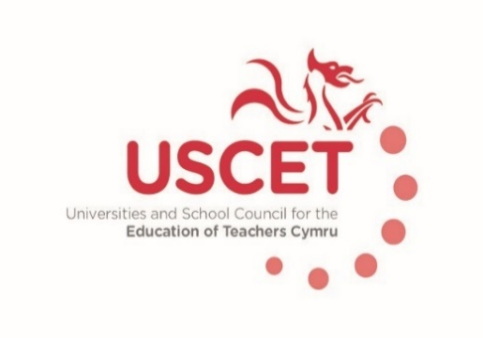

Minutes of the meeting of the Universities and Schools Council for the Education of Teachers held on Thursday 18 October2018 at the Media Resource Centre, Oxford Road, Llandrindod Wells, LD1 6AH

Attendance:

Mathew Jones (for Elaine Sharpling, Director of Initial Teacher Education, University of Wales Trinity Saint David
Jonathan Davies, Assistant Head, Treorchy Comprehensive
Nicola Thomas, Crickhowell High School
Mel Williams, Assistant Headteacher, Northop Hall Primary
Paul Davies, GWE
Mandy Esseen, South Central Consortium
Jon Murphy, Headteacher, Llanfoist Primary School
Julia Longville, Cardiff Metropolitan University
Gill Ellis, Blenheim Community Primary School
Catherine Bleasdale, University of Wales Trinity Saint David
Owen Evans, Teach First
Lisa Taylor University of South Wales
Tracy Eastment, Cardiff University
Malcolm Thomas, Aberystwyth University
John Luker, Glyndwr University
Hazel Wordsworth, Bangor University
School, Flintshire
James Noble-Rogers (UCET)
Jackie Moses (UCET)

Apologies: ?

Minutes of the previous meeting

The minutes of the meeting held on 19 October were agreed.

All matters arising are covered by the agenda

Election of a new chair
This was discussed and agreed that JNR would circulate the membership asking for nominations, new Chair and Vice Chair to be in place for the January meeting (James did this also include VC?)
Terms of reference for USCET
This was discussed in some details and JNR agreed to update the paper and recirculate to the membership. Important to remain as flexible & inclusive as possible.
Key points on
Membership
- One HEI and one school representative per partnership (if 2 HEIs in partnership then two reps)
- Include representation from the College/FE sector
- Include Chairs of working groups if not already a member
Purpose
- Important to be seen as key partner and engage as widely as possible especially with Welsh Government, number of new members so meeting with Kevin Palmer on 13 December is important
- Continue to have Government, Estyn and UWC in attendance for part of meeting, also invite representation form the new National Academy (GE is an Associate and may be able to represent)
Working Groups (confirmed that meeting costs and venue hire can be covered from budget)
- Research
- Quality assurance
- Marketing & Recruitment
- Post compulsory CPD
- National Mission/priorities
Partnership working cuts across all working groups

Agreed to hold seminar discussion at next meeting around what constitutes partnership and how will this work. Important to re-establish a cooperative working environment. The new Charis to facilitate this session

Priorities for USCET for the year ahead

- Partnership & what this means
- Establish USCET as the ‘go to’ organisation on teacher education in Wales
- Research agenda, establish a collaborative project for USCET
- PCET agenda and Welsh policy on this
- Implications of policy changes in England and its impact(e.g. ECF, new marketing and recruitment strategy, student fees)

Roles of panel members
Discussion over Chair of working groups, their remit and attendance at USCET meetings. Agreed that they should be there if not already in some other guise.

Strategic Stakeholder meeting – Sept 13th (MT)
Papers previous circulated and MT gave brief overview

Update from providers including accreditation details, programmes and next steps for 2018/19
MT – Estyn’s role in regards the inspection of legacy programmes during the transition to courses delivered by the new partnerships requires clarification. Agreed question for later meeting
What is role of HEFCW with regard to HEIs, what is their QA relationship with ITT, this also needs clarifying

TE – What is happening in post compulsory education? Felt that Post compulsory is the ‘poor relative’’ where are the standards that were started 198months ago? Estyn don’t inspect although has been discussion about them doing this. Concern around moment between post compulsory and compulsory sector once qualified, very grey area that needs addressing
JNR agreed to ask Kevin palmer who the new contact should be.

LT – Clarification re UG programmes and their run out time vis a vis the new standards. Previous agreement was thought to be that the new standards would apply to all those beginning programmes in September 2019, and that existing undergraduate students would continue to be formally judged against the existing standards, with mapping across the new standards carried out at institutional level.

USCET contribution to UCET conference

JNR reminded meeting of the UCET Conference in Stratford Upon Avon in November and that their conference fees and accommodation could be paid for from the delegated USCET budget

Any other Business

None raised

Date of next meeting

31 January 2019
16 May 2019
Venues to be confirmed

