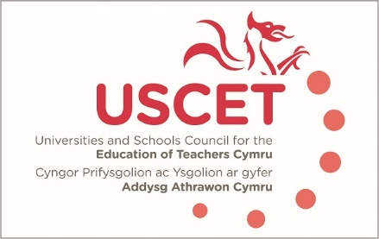

Agenda for the meeting of the University and Schools Council for the Education of Teachers (USCET) to be held at 10am on Thursday 16 May 2019 at the Media Resource Centre, Oxford Rd, Llandrindod Wells LD1 6AH

10.00am-10.45am:
- Welcome & introduction
- Minutes & matters arising
- Vice Chair of USCET
- Updates from regional consortia and accredited providers
- USCET sub groups:
  - Reports from sub-groups
  - Membership and chair of PCET group
  - Membership and chair of research group
- Report from December and March meetings with Kevin Palmer
- USCET conference/day event
- Literacy and numeracy tests
- Entry requirements for ITE
- Equivalency tests – Final Report January 2019
- WG plans for Welsh Language Development
- WG plans for accreditation framework for PL
- ITE developments in other parts of the UK
- UCET Easter 2019 newsletter
10.45-11.30pm:
- Open discussion: What do we mean by partnership working, within and across partnerships?
11.30am-12.30pm:
Welsh Government, EWC, Qualification Wales and Estyn colleagues to join meeting
- Updates from:
  - Welsh Government
  - Estyn
  - Education Workforce Council
  - Qualifications Wales
- Accreditation of programmes and the allocation of ITE places
- Equivalency tests
- Professional Learning Passport
- PCET issues
12.30-1.00pm: Lunch

