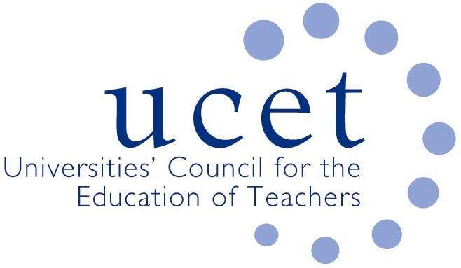
A Registered Charity (No 275082)

9-11 Endsleigh Gardens, London WC1H 0EH

T: 020 7621 6836
info@ucet.ac.uk

Promoting Quality in Teacher Education

Note of the meeting of the UCET Research & International Forum held at 1pm on Tuesday 22nd January 2019 at Friends Meeting House, Euston Road, London NW1 2BJ

Welcome, introductions and note of the previous meeting

Forum colleagues were welcomed to the meeting. The note of the meeting held on 9th October 2018 was approved. On matters arising: There were no matters arising.

Discussions:

Forum members discussed a range of topics linked to the meeting agenda, including:

- Updates from UCET on non-R&I forum issues, including: ITE recruitment; the Early career Framework, Apprenticeships & updates from Wales and NI.
- Feedback from the morning symposium: Three presentations were given by Alan Clapham (What I wish I knew about Impact), Heather Smith (Reach & Significance) & Linda LaVelle. (Brief timeline and update on Ref 2021). The PowerPoints for these are available on the website.
- Discussion on ‘How to define Signiant Responsibility to Research’. Key points
- Many different practices across the sector
- How we construct and what we include in the environment statement?
- How do we capture and allocate hours & the differing contracts?
- How we ensure time for the impact case studies in addition to research time
- Dealing with the pressure of 3* outputs
Would be useful if UCET were to undertake a short survey to capture this information.
- Ideas for morning symposia include:
- Writing the environment statement; Alex to share her presentation from the UCET Conference on working workshops (may also be a 20min agenda item)
- Writing retreats were discussed but it was felt at this point these were not something that would be well attended partly as a number of HEIs already offer these themselves
Linda LeVelle talked to the publication on Building Research Informed Communities. It was agreed this should be published on the website, LDeV would send a copy to Gary McCulloch at BERA for publication in Research Intelligence. A copy has also been sent to CCoT for publication/a reference to in their Impact Journal. LDeV would also hold a case study writing workshop at the next UCET Conference. LDeV also asked those present for contributions of case studies and explained that she has a template ready for these to be submitted on.
- International updates: none offered. Likely that the last round of Erasmus funding will be this February. Meeting were informed of another area of funding, namely the Transatlantic Platform.
- The criteria for the Gordon Kirk Travel Scholarship was raised and the meeting agreed to leave it as it stands.
- Information given on the ICET Conference in Johannesburg, S Africa from 9-11 July 2019, call for paper now open.
Date of next meeting

14 May 2019

