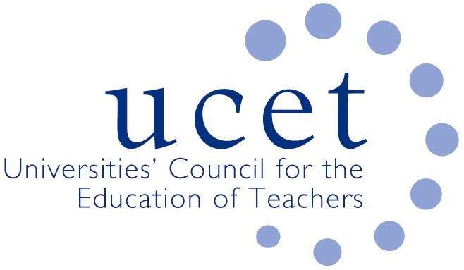
A Registered Charity (No 275082)

Promoting Quality in Teacher Education

Agenda for the meeting of the Research & International Forum to be held at 1pm on Tuesday 14 May 2019 at Mary Sumner House, Tufton Street, London SW1P 3RB

There will also be a morning symposium beginning at 10.15am on the Research Excellence Framework led by REF 2021 education sub-panel chair David James. If you would like to attend but have not registered please contact Max Fincher at: m.fincher@ucet.ac.uk.

- Welcome and introductions
- Minutes of the previous meeting
- Matters arising
- UCET updates
- Research Excellence Framework:
  - Feedback from morning meeting
  - Institutional environmental pilot (enc.)
  - Other REF issues
- Topics for future symposia
- Intellectual base of teacher education group: minutes of initial meetings (encs.)
- 2019 UCET conference: research strand at conference
- Horizon scanning and institutional level reports
- International issues:
  - Trends shaping education report (enc.)
  - 2019 Gordon Kirk travel scholarships
  - 2019 ICET conference (enc.)
  - Feedback from forum members on international activities.
- Items for information:
  - Joint letter from UCET, NASBTT, TSC and CCT to Damian Hinds, & response
  - Correspondence with Minister of State Ann Milton
  - Schools Week article Early Career Framework
  - Response to OFSTED EIF consultation
  - Easter 2019 UCET newsletter
- Any other business
- Date of next meeting: tbc

Background papers

- Minutes of the previous meeting
- REF environment paper
- OECD trends shaping education paper
- Note of IBTE meeting & values document
- Joint UCE, CCT, NASBTT and TSC letter and Secretary of State’s response
- Correspondence with Ann Milton
- JNR Schools Week article on ECF
- Response to Education Inspection Framework consultation
- UCET Easter 2019 newsletter

