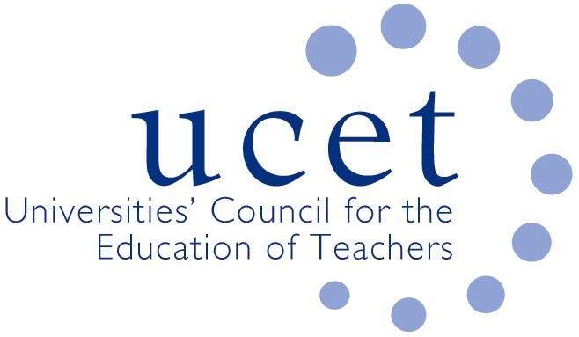
A Registered Charity (No 275082)

9-11 Endsleigh Gardens, London WC1H 0EH

T: 020 7621 6836
info@ucet.ac.uk

Promoting Quality in Teacher Education

Note of the meeting of the UCET Post 16 Forum held at 1pm on Friday 19 October 2018 at Mary Sumner House, Westminster, London SW1P 3RB

Welcome, introductions and note of the previous meeting

Forum colleagues were welcomed to the meeting by the new Chair (Karen McGrath) and Vice Chair (Russell Shobrook). The note of the meeting held on 11 May 2018 was approved and there were no matters arising

Discussions:

Forum members discussed a range of issues linked to the meeting agenda, including:

- Updates from UCET on non-Post 16 forum issues, including: recruitment to QTS programmes in 2018, which was expected to be on par with that for 2017; limited levels of recruitment to the QTS apprenticeship; the development of the early career framework for NQTs; and research issues (REF and UCET research in teacher education paper).
- Recruitment to PCET teacher education programmes, including feedback on morning symposium presentations from Karen McGrath and Russell Shobrook about strategies undertaken in their institutions, followed by an update from DFE colleagues Eligio Cerval-Pena and Pete Grady on latest policy developments relating to teaching qualification expectations, teacher recruitment and quality assurance. It was agreed that the topic for the next morning meeting would be teacher education in respect of mental health, well-being and resilience. The next meeting would also include Kevin Orr on the teacher education resources developed at Huddersfield. Future symposia might include apprenticeships (including the selection and role of EPAs); and the new OFSTED inspection framework.
- The regulation and quality assurance of teacher education qualifications, including the identification of key points to make at the forthcoming meeting between UCET and Minister of State Ann Milton
- JNR’s paper on the current landscape for HEIs and teacher education, and JNR’s willingness to visit HEI colleagues for briefing sessions
- An update from Howard Pilot from the Education & Training Foundation covering: subject specific training videos; a forthcoming on-line resource on training for teacher trainers, building on training events provided at SHU, Bolton and WMCETT; a CPD module on SEND for non-SEND specialists developed by Bolton (and which might, it was suggested, be linked to the training the teacher training resource); a reminder that membership of the Society for Education & Training was free to trainees until Match 2019; and the processes for reviewing the level 5 DET, where the need for lead-in timers to allow for revalidation of programmes, QTLS transition and the existence of two-year programmes was noted (changes to be agreed by July 2019, for implementation in September 2020).
- Inspection issues, where no stage 2 inspections had recently taken place.
- The 6-7 November UCET conference in Stratford upon Avon.
- AOB, where issues of the eligibility of part time pre-service trainees to student support were noted.

A number of papers, including the summer 2018 UCET newsletter, were noted for information.

Date of next meeting

8 February 2019, Mary Sumner House

