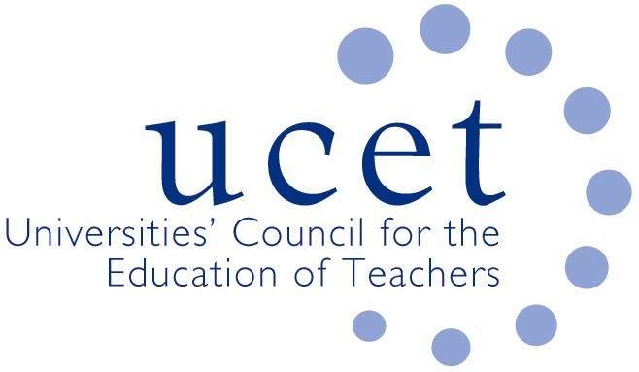
A Registered Charity (No 275082)

Promoting Quality in Teacher Education

Agenda for the meeting of the CPD Forum to be held at 1pm on Tuesday 12 February 2019 at Mary Sumner House, 24 Tufton Street, London SW1P 3RB

There will also be a morning symposium beginning at 10:00 am : the intellectual base of CPD teacher education programmes. Contributors will include: Tracey France (Worcester) on Effective Leaders, Successful Schools and Effective Teachers, Successful Learners; Christine Harrison (King’s) on teacher assessment capability; Jon James (Bristol) on non-deficit based models of teacher development; and Rachel Lofthouse (Leeds Becket) on Collective Ed as an example of the integration of research & practice in support of CPD. . If you would like to attend but have not registered please contact Max Fincher at: m.fincher@ucet.ac.uk.

- Welcome and introductions
- Minutes of the previous meeting (enc.)
- Matters arising
- UCET updates
- Morning symposia:
  - Feedback from morning symposium
  - Topics for future symposia
- Early Career Framework for new teachers & DFE teacher recruitment & retention strategy (encs.)
- NFER report on teacher recruitment & retention (hyperlink)
- Horizon scanning & institutional updates
- Middle and senior leadership apprenticeships
- International issues:
  - Report from Rachel Lofthouse on coaching, mentoring and teacher induction in Western Quebec
  - 2019 ICET conference (enc.)
  - Feedback on international activities from CPD forum members
  - Gordon Kirk Travel Scholarship (enc.)
- Items for information:
  - December 2018 UCET newsletter (enc.)
- Any other business
- Date of next meeting: 14 June 2019

