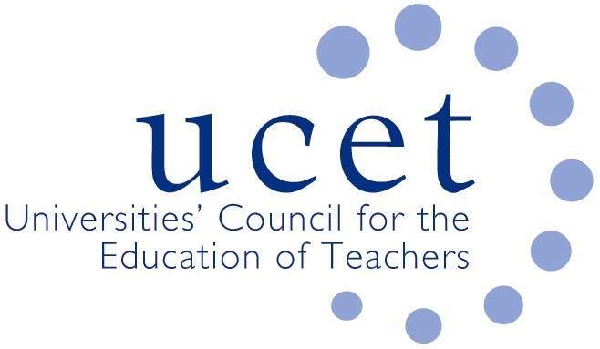
A Registered Charity (No 275082)

9-11 Endsleigh Gardens, London WC1H 0EH

T: 020 7621 6836
info@ucet.ac.uk

Promoting Quality in Teacher Education

Minutes of the UCET Executive Committee meeting held at 10:00 am. – 12:00 p.m. on 8th January 2019, Mary Sumner House, 24 Tufton Street, London SW1P 3RB

Attendance

Moyra Boylan
Pat Black
Sean Cavan
Caroline Daly
Max Fincher
Julie Greer
Alex Kendall
Kevin Mattinson (Chair)
Karen McGrath
Jackie Moses
Margaret Mulholland
Trevor Mutton
James Noble-Rogers
Tanya Ovenden-Hope
Jim Pugh
Cat Scutt
Simon Thompson
Matt Varley
Alison Winson
Roger Woods

Apologies:

Linda Clarke; Rachael Harding; Emma Hollis; Rachel Lofthouse; Linda la Velle; Malcolm Thomas.

- Welcome & introductions

Members introduced themselves to the Executive committee. Kevin Mattinson agreed to chair the meeting.

- Declarations of Interest

None.

- Minutes of the previous meeting & matters arising

The previous minutes were agreed as accurate. Under matters arising:
- Under (6), once the remaining case studies have been added, the ‘Building research-informed teacher education communities UCET paper’ will be finalized. JNR thanks both AK and LlaV for their work.
- Under (9), CD and JG are drafting a response to the recent ‘Addressing Workload’ report by the DfE.

- Risk Register

- The issue of the current proposal for reviewing tuition fees needs to be considered.
- The cutting of funding for teaching assistants would impact on every aspect of teaching.
- KM and JNR to draft a response to the proposed tuition fees changes.
- A ‘no-deal’ Brexit might have serious implications for university providers of teacher training overall, including a reduction in the recruitment of EU students.
- More regular and in-depth discussion with OFSTED is need about their new strategy. It was suggested that OFSTED, as well as attending the Executive Committee, should also be invited to some of the UCET forums. It was agreed to ask them at the afternoon meeting.

- Executive Director update:

- JNR provided a summary of recent meetings since the last Executive, including a meeting with Nick Gibb, chaired by the DfE Director General, where the use of apprenticeship funding was raised. JNR and Emma Hollis also had a meeting at the DfE about the Early Career Framework (an announcement is expected on Thursday 10th January about publication). JNR also met with Kevin Palmer from the Welsh Government who agreed to the need for stability in the accreditation of programmes across Welsh providers.

- Financial matters:

- Annual report & accounts for 2017/18
- RW drew attention to the fact that the accounts were unaudited, and explained why an independent examiner, via Peter Elmworth & Moore, UCET’s accountants, was chosen to approve the accounts this year. It was proposed to use this method going forward to save both time and money. RW produced a report that will be circulated.
- Report on investments
- The investments are currently performing well, and the accounts are in good shape. Nevertheless, there are concerns:
- In the wake of Brexit, especially a ‘no-deal’ Brexit, the investment manager for UCET is concerned that UCET’s investments may not perform so well as they have done to date.
- Conference and forum income has decreased by 25% over the last 4 years. RW drew attention to p.15 of the accounts which summarized the total income and expenditure.
- JNR noted that the figure of £39,000 should take into account writing off some debts, the new UCET website and staff restructuring/redundancy costs, and that UCET has broken even. It was noted that in the medium term, UCET’s office base may be lost, but that the majority of the administrative work is currently done from home anyway.
- It was suggested that some thought might be given to the content of workshops to attract more delegates, and that timing/travel to workshops might affect attendance. It was also suggested possibly make approaches to those involved in teacher training for legacy funding.
- RW thanked the efficiency of UCET’s administrative staff for their work on the accounts/finances throughout the year.
- KM thanked RW for the overview.

- ITE Recruitment:

- Recruitment in 2018/19
JNR summarized the figures, noting in particular that for the 7th year running, recruitment to Primary has missed its target, that EYTT is down significantly, and that 90 people were recruited via the apprenticeship route. There has been a negligible net increase in recruitment.
- Feedback on applications for 2019/2020
- Applications are in general down compared to 2018/2019.
- Fewer EU nationals are applying to teacher training.
- There has been no change in the bursary funding.
- MF to add on to the UCET website a poll asking members: ‘Have applications to Primary and Secondary programmes a) increased, b) remained the same or c) decreased this year compared to last year?’
- ECF
It was noted that the ECF can only work if the funding structure follows it. Different parts of the DfE and sending out different messages. On the issue of mentoring for instance, there is some acknowledgment from the DfE that a model or framework is needed within the ECF.

- Developments in Scotland, Wales and Northern Ireland

Moyra Boland (University of Glasgow) provided an overview of developments in Scotland noting in particular that:
- The Scottish Government and universities are focused on STEM, and also reaching rural areas.
- There are bursaries for STEM subjects that have been introduced by the Scottish Funding Council, and that a change in the gender balance is needed in new recruits, with 70 (male): 30 (female) aimed for by 2020.
- The GTC Scotland has recently revised its standards for entry to the profession. Education Scotland (the equivalent of OFSTED) is developing a QA framework, and also reviewing career progression for teachers.
- It is mandatory in Scotland for there to be evidence of CPD and professional development training for teachers.
- Students are exempt from postgraduate fees in Scotland.
- MB agreed to give an overview of Scotland at this year’s UCET Annual Conference.
- JNR noted that USCET Wales has organized a 1 day conference in Wales for TE providers.
- In May, there will be a showcasing event in Ireland, to which all the NI universities and the Inspectorate will contribute; the two funded research projects administered by UCET Northern Ireland, Professional Learning Frameworks and DigiSkills, are progressing well.

- Arrangements for the afternoon meeting
None.
- AOB
The Executive Committee was asked to look at hard copies of the accounts, and raise anything at the AGM which would follow immediately. KM thanked RW for his contribution.
- Date of next meeting: 10:30 am – 12:00 pm on 26th March.

