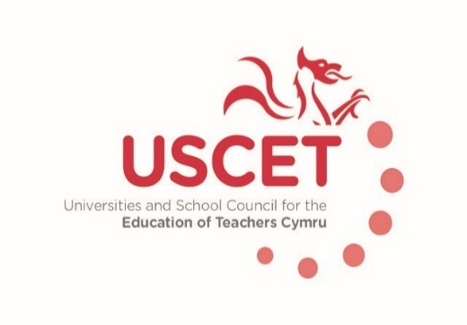

Terms of reference: Universities and Schools Council for the Education of Teachers, Cymru

Background
The Universities and Schools Council for the Education of Teachers (USCET), Cymru, is a representative body for partnerships involved in the delivery of teacher education programmes under the terms of the regulatory and funding systems operating within Wales.
Membership
The original membership of USCET will be comprised of: the universities that were formerly members of UCET Cymru; and representatives of each of the regional consortia in Wales (GWE, Central South Consortium Joint Education Service, the South East Wales Education Achievement Service; and ERW).
Once new teacher education partnerships have been accredited, reflecting the outcome of the accreditation process concluding in June 2018, the membership will be:
- XX members from each of the higher education institutions involved in the delivery of accredited ITE programmes;
- XX members from schools from each accredited ITE partnership;
- If not already covered by the above two categories, one member from each further university involved in: post-compulsory teacher education for teachers; continuing professional development; and/or education research;
- X member(s) from each of the regional consortia; and
- Up to three co-opted members to serve for terms of up to three years, with scope for subsequent renewal, to ensure an appropriate balance of membership between schools, colleges, universities and other organisations, and to ensure access to required levels of knowledge and expertise.
Purpose
The purpose of USCET will be to champion the contribution that teacher education delivered in partnership between universities, schools, colleges and other organisations can make to a self-improving and sustainable education system. It will advocate on behalf of its member organisations and engage in constructive dialogue with government, regulatory agencies and other organisations. It will share information and ideas about all aspects of teacher education. In particular, it will:
- Represent providers and other USCET members involved in the delivery of accredited teacher education programmes in discussions with the Welsh Government, Estyn, the Education Workforce Council, the Higher Education Funding Council for Wales, UCAS teacher training and other relevant organisations;
- Debate policy positions relating to teacher education and education research (while allowing for distinct positions to be adopted by individual members) including (but not restricted to): recruitment to teacher education programmes; the content and structure of teacher education; quality assurance; partnerships between schools, colleges, universities and other organisations; the links between ITE and early and continuous professional development; education leadership; and education research; and
- Share knowledge and expertise on all aspects of teacher education and education research.
Chair and Vice Chair
USCET will elect a Chair and a Vice Chair to serve for periods of up to three years. The holder of each position will alternate between representatives from HEIs and representatives from schools. While the position of Chair is held by an HEI colleague, the position of Vice Chair will be held by someone from a school, and vice-versa.
Meetings
Meetings will take place at least once every term in each academic year, with scope to hold additional meetings as required. All members of USCET will be required to declare any potential conflicts of interest at the start of each meeting. Meetings will be deemed quorate if XX or more member institutions are represented. Should a quorum not be achieved, meetings can proceed although any decisions will have to be ratified by a quorate group either by email or at a separate meeting.
The location of meetings will be agreed prior to the beginning of each academic year. Use of remote communications using skype, video conferencing etc will be facilitated wherever possible.
Sub-groups and working groups
USCET will have the authority to establish (and de-establish) sub groups and working groups to discuss and consider particular issues or areas of teacher education as it considers appropriate from time to time. Any decisions taken by such groups should be subject to ratification by USCET.
Representing USCET
USCET will, from time to time, commission individuals from within its membership to represent it at meetings, events and in other forums. In such circumstances, such individuals will always speak on behalf, and represent the interests, of USCET collectively rather than their own particular organisations or institutions.
Funding
Each member of USCET (former members of CET Cymru) will pay an annual subscription equivalent to the rate paid by UK members of UCET. The total amount paid is (after a deduction to cover central costs) devolved for USCET to use for any purposes consistent with its terms of reference. This includes, but not be restricted to: the cost of meetings & events; translation services; and attendance at external events.
Future funding arrangements will be made by USCET in the light of decisions about the accreditation of ITE programmes in 2018/19 onwards. It is envisaged that responsibilities for funding will be shared across the different constituencies within teacher education partnerships.
USCET will have the scope to secure external funding for particular projects and activities. This should not however compromise, or appear to compromise, its independence and integrity.
Relationship with UCET as a UK wide organisation
The Universities Council for the Education of Teachers is a UK wide membership organisation for universities and other organisations involved in teacher education and education research. Teacher education partnerships in Wales will be eligible for full UCET membership and be entitled to the same benefits and services as other UCET members. Members of USCET will have automatic representation in each UCET standing committee. The chair of USCET will be a member of the UCET Executive Committee.
Staff from UCET will attend meetings of USCET to provide advice and secretarial support.
Review
These terms of reference will be subject to regular review, beginning in 2018/19.

USCET
March 2017

£4,050 in 2016/17.

